CALIFORNIA STATE UNIVERSITY, NORTHRIDGE

Parking Detection using MATLAB and Xilinx

A graduate project submitted in partial fulfillment of the requirements

For the degree of Master of Science in Electrical Engineering

By

Ryan Mark

May 2025

# Signature Page

The graduate project of Ryan Mark is approved:

_____________________________________________ __________

Dr. Xiaojun Geng Date

_____________________________________________ __________

Dr. Myung Cho Date

_____________________________________________ __________

Dr. Shahnam Mirzaei, Chair Date

California State University, Northridge

# Acknowledgement

I am truly appreciative of my committee for their unwavering support throughout this project. First and foremost, I would like to express my deepest gratitude to Dr. Mirzaei for his invaluable guidance and support. I am also grateful for the courses I have taken with him, which have greatly contributed to my academic growth. Additionally, I would like to thank Dr. Cho for serving on my committee and for being an excellent resource for MATLAB. Lastly, I extend my sincere appreciation to Dr. Geng for being a dedicated member of my committee, an exceptional undergraduate advisor during my time as an undergraduate student, and an outstanding department chair throughout my graduate studies.

# Dedication

This graduate project is dedicated to my loving family, my late grandfather Hiroshi Yamaguchi, my grandmother Yoshiko Yamaguchi, my mother Junko Mark, and my twin brother Dylan Mark. I also want to dedicate this to all the friends I made during my time at CSUN and Los Angeles Valley College. They have all been supportive at some point during my journey towards my undergraduate and graduate degrees. Without them, I don’t know if I would have come as far or have grown to become the person I am today and will always be thankful for all my friends and family who have been there for me.

Table of Content

Signature Page ii

Acknowledgement iii

Dedication iv

List of Figures vii

List of Acronyms ix

Abstract x

Chapter 1 Introduction 1

1.1 Image processing 1

1.2 Morphological Operations 2

1.2.1 Erosion 2

1.2.2 Dilation 3

1.2.3 Closing 4

1.2.4 Opening 5

1.3 Zybo Z7-100 6

1.4 Implementation 7

Chapter 2 MATLAB Implementation 8

2.1 Setup 8

2.2 Getting the Binary Parking Lot Mask 11

2.3 Getting the binary car mask 12

2.4 Detecting cars in MATLAB 16

Chapter 3 Hardware 19

3.1 Setup 19

3.2 Creating Block design for Hardware 21

3.2.1 Zynq processing system 22

3.2.2 Video Interface 22

3.2.3 GPIO 27

3.3 Generating bitstream 28

Chapter 4 Software Design 31

4.1 Setup 31

4.2 Software algorithm 34

4.2.1 Displaying Image 36

4.2.2 Detecting cars in Xilinx 37

4.2.3 Single Buffering vs Double Buffering 37

Chapter 5 Results and Conclusion 39

5.1 Equipment Setup 39

5.2 Simulation 41

5.3 Results 41

5.4 Future work 46

5.5 Conclusion 46

References 48

Appendix A 49

Detect_parking_space.m MATLAB file 49

Appendix B 53

Morph_Cars.m MATLAB Function file 53

Appendix C 56

Image_write.m MATLAB file 56

Appendix D 58

Vitis C code 58

# List of Figures

Figure 1.1: RGB in a single 24-bit value [1] 1

Figure 1.2 The car mask before (left) and after (right) morphological operations is applied 2

Figure 1.3: The process of erosion is being performed [2] 3

Figure 1.4: The process of dilation being performed [2] 4

Figure 1.5: Car mask with holes before closing (left) and patched holes after closing is applied (right) 5

Figure 1.6: Car mask with fused cars before opening (left) and detached objects after opening is applied (right) 5

Figure 1.7: The Zybo Z7-10 board [3] 6

Figure 2.1: Filled parking lot with cars [4] 8

Figure 2.2: Empty parking lot 9

Figure 2.3: parking lot Mask 10

Figure 2.4: RGB image channel in MATLAB [1] 10

Figure 2.5: Parking mask after maxing it 11

Figure 2.6: Extracted coordinates of every parking lot space in the image. 12

Figure 2.7: Flowchart on extracting cars from the original image. 12

Figure 2.8: Difference image result between the filled parking lot and the empty parking lot 13

Figure 2.9: Gray scaled cars 14

Figure 2.10: Car mask after applying a threshold of 16 15

Figure 2.11: Sample of zero padding being applied to an image in matrix form [1] 16

Figure 2.12: Filled parking with detected cars 17

Figure 2.13: Filled parking lot with displayed coordinates 18

Figure 3.1: Creating project 19

Figure 3.2: Selecting the Zybo Z7-10 board 20

Figure 3.3 VGA PMOD [5] 20

Figure 3.4: Full block design used for this project 21

Figure 3.5: Zynq processor subsystem 22

Figure 3.6: Zynq processor clock path to clocking wizard 23

Figure 3.7: AXI4S to Video Out IP block 23

Figure 3.8: Video timing controller IP block 24

Figure 3.9: Video processing system IP design 24

Figure 3.10: Pin mapping from the VGA PMOD to the Zybo 25

Figure 3.11: VDMA IP block 25

Figure 3.12: VDMA processing data path [6] 26

Figure 3.13: Read and write pathway for single buffer 27

Figure 3.14: Read and write pathway for double buffer 27

Figure 3.15: GPIO IP block for the switches and push buttons. 28

Figure 3.16: Elaborated Design 29

Figure 3.17: Implemented design 30

Figure 4.1: Creating a project in Vitis 31

Figure 4.2: Selecting wrapper that contain bitstream 32

Figure 4.3: Exported GPIO defined for push button and switches 33

Figure 4.4: Exported VDMA defined 33

Figure 4.5: Raw data of the car mask and parking mask 34

Figure 4.6: Raw data of the colored car original input image 34

Figure 4.7: Block diagram for the algorithm in the embedded loop 35

Figure 4.8: Display functions used to display 36

Figure 4.9: Centroid data from MATLAB 37

Figure 4.10: Image transitioning having screen tearing from using only a single buffer 38

Figure 4.11: Image transitioning with no screen tear through double buffering. 38

Figure 5.1: FPGA board connected to VGA PMOD 39

Figure 5.2: Laptop 40

Figure 5.3: Monitor 40

Figure 5.4: Build successful 41

Figure 5.5: FPGA being programmed 41

Figure 5.6: Displaying the colored parking lot image 42

Figure 5.7: Displaying Car mask when the push button value is at 1 42

Figure 5.8: Displaying the parking lot mask when push button value is 2 43

Figure 5.9: 4-bit switch value at 1, choosing to evaluate parking lot 1 43

Figure 5.10: Case of car being detected 44

Figure 5.11: Red x being marked in the taken parking spot 1 44

Figure 5.12: 4-bit switch value at 8 choosing to evaluate parking lot 8 45

Figure 5.13: Case of a parking space being free 45

Figure 5.14: Green circle being drawn in response of parking lot 8 being free 46

# List of Acronyms

* FPGA – Field Programmable Gate Array
* SE – Structuring Element
* VDMA – Video Direct Memory Access
* VHDL – Very High-Speed Integrated Circuit (VHSIC) Hardware Description Language
* VGA – Video Graphic Array
* IP – Intellectual Property
* MHz – Megahertz
* GPIO – General Purpose Input Output
* PL –Programable Logic
* PS –Processing System

# Abstract

Parking Detection using MATLAB and Xilinx

By

Ryan Mark

Master of Science in Electrical Engineering

This paper presents a parking space detection project that utilizes image segmentation techniques to detect cars in the parking lots. This project will analyze three specific images: an image of the parking lot filled with cars, an image of the parking lot empty, and finally an image with white rectangles covering each parking lot. The project employs image processing techniques such as morphological operations to accurately detect and extract vehicles from the parking area.

This project will be implemented using both MATLAB and Xilinx platforms. MATLAB will be used to perform all image processing tasks and to record the results. The Xilinx implementation will utilize the Zybo Z7-10 board in conjunction with the VGA PMOD to display the results generated in MATLAB. By analyzing the image of the extracted cars and the mask of all the parking lots, the board will identify available parking spaces within specified areas as directed by the FPGA board.

# Introduction

## 1.1 Image processing

Image processing does some transformations on images, such as smoothing, sharpening, contrasting, and stretching, for enhancing images and improve their readability. It can be used in many practical applications such as medical imaging, surveillance systems, object detection, and many more. In these practical applications, techniques such as thresholding, edge detection, and image segmentation are also used to extract vital information or even make masks for object detection purposes.

Before any image processing is done on any image, they are gray scaled in order to reduce it from a 3d image to a 2d image. Color images are difficult to process in their current state due to having three channels. Each channel stores an 8-bit pixel ranging from 0 to 255. The channels are presented as red, green blue (RGB), making a total of 24 bits in a single-color pixel. Figure 1.1 illustrates how a colored pixel is represented in an RGB image.

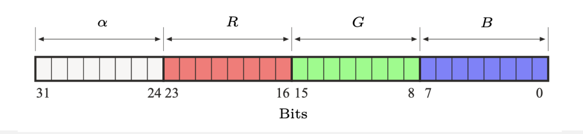

Figure 1.1: RGB in a single 24-bit value [1]

When an image is gray scaled the image represented in one channel. Pixel intensities going towards 0 become black and pixel intensities going towards 255 become white.

## 1.2 Morphological Operations

Morphological operations are image segmentation techniques that help reduce noise in a binarized image and enhance the distinction of objects within it. A morphological operation uses a kernel, also known as an SE, which defines the neighborhood of pixels to which the operation is applied. Figure 1.2 shows the car mask before and after the morphological operation is applied to it.

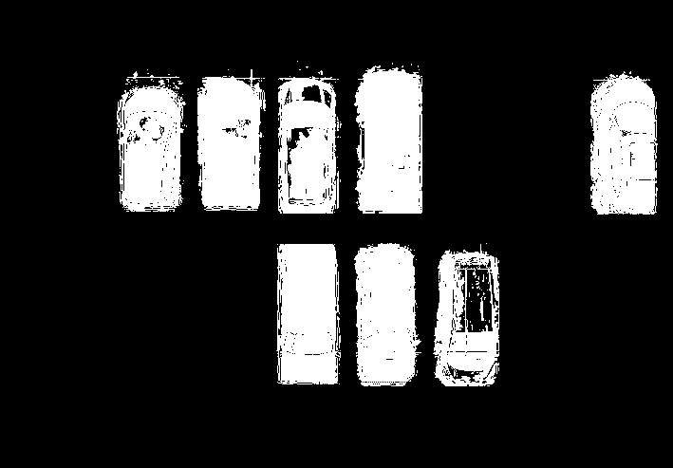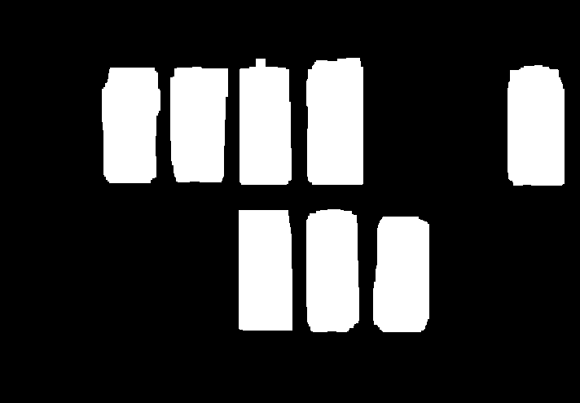

Figure 1.2 The car mask before (left) and after (right) morphological operations is applied

### 1.2.1 Erosion

The erosion morphological operation removes pixels from an object boundary in the binary image based on the SE. Erosion is used to separate connected objects by eroding the connection. One flaw of the erosion is that if there are holes present in the binary image, it will end up enlarging the holes. In the worst-case scenario, if a large SE is used, it can completely destroy the object. Figure 1.3 shows an example of an erosion being applied.

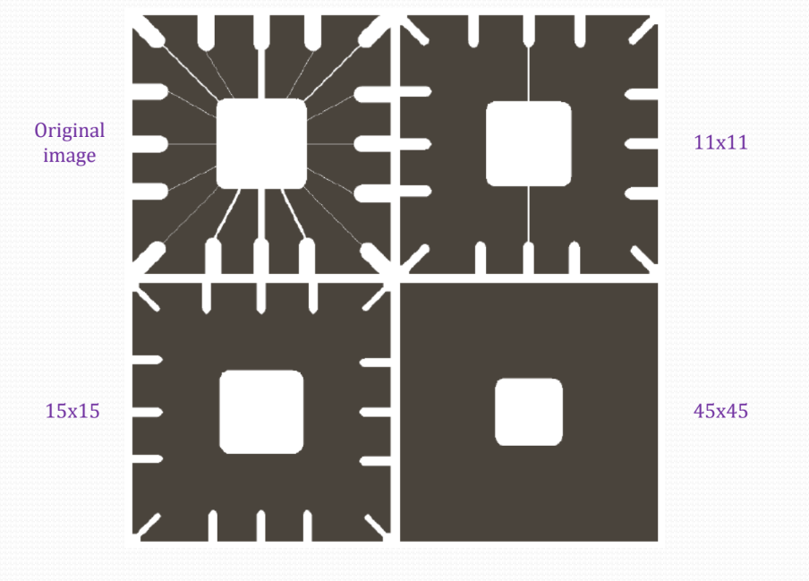

Figure 1.3: The process of erosion is being performed [2]

### 1.2.2 Dilation

Dilation is a morphological operation that helps repair holes in objects within an image by enlarging their boundaries. It is particularly effective when the goal is to refine a single object, making it appear cleaner and free of internal gaps. However, a limitation of dilation is that when multiple objects are positioned close to one another, it often causes them to merge into a single connected region. In the worst-case scenario, if a huge SE is used for this operation, it could result in 2 objects completely fusing into one big object. This will make the 2 objects no longer distinguishable from one another. Figure 1.4 shows an example of dilation being applied to an object.

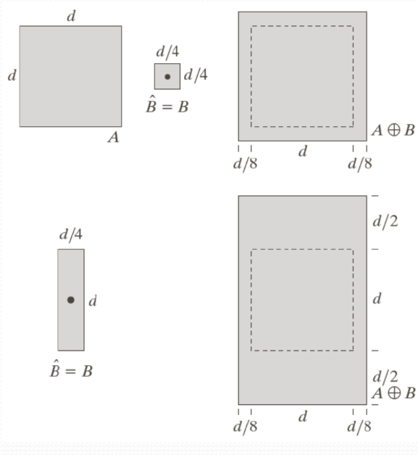

Figure 1.4: The process of dilation being performed [2]

### 1.2.3 Closing

Closing is an advanced morphological operation that performs a dilation followed by an erosion operation. This sequence allows us to, for the most part, shrink an object back to its original size while still patching up any holes in the binary image. Figure 1.5 illustrates the application of the closing operation on the car mask that was developed for this project after having a threshold applied to it.

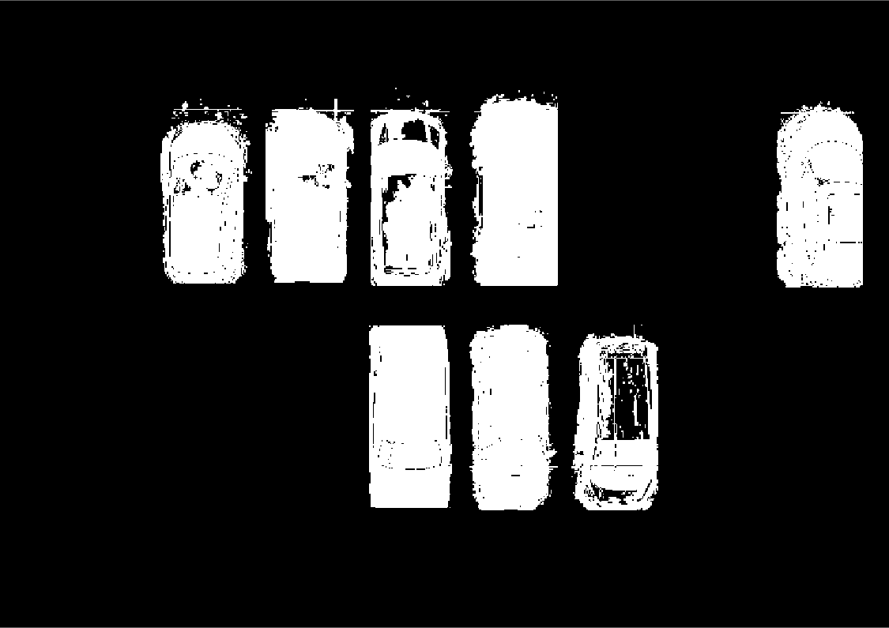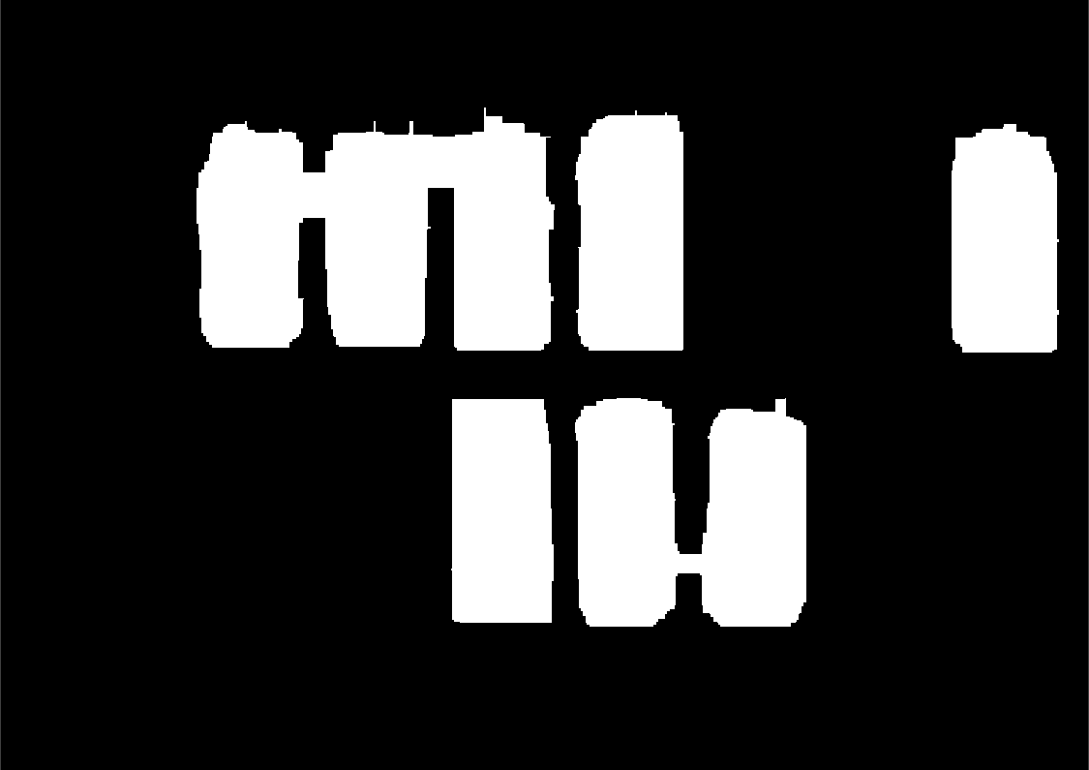

Figure 1.5: Car mask with holes before closing (left) and patched holes after closing is applied (right)

### 1.2.4 Opening

Opening is an advanced morphological operation that is the counterpart of closing, which involves performing an erosion followed by a dilation. This sequence is applied to closely restore the object's original size after it has been reduced by erosion. Opening is particularly useful for disconnecting objects in a binary image while maintaining a shape close to their original form. Figure 1.6 illustrates the application of the opening operation on the car mask that was developed for this project after closing was applied to it.



Figure 1.6: Car mask with fused cars before opening (left) and detached objects after opening is applied (right)

## 1.3 Zybo Z7-10

The Zybo Z7-10 is an FPGA development board designed by Digilent and based on Xilinx Zynq-7000 technology. It is commonly used in embedded systems to perform complex tasks through a combination of programmable hardware and software. The board features a dual-core ARM Cortex-A9 processor integrated with Artix-7 FPGA fabric. The board features 3 PMOD connectors, which allow us to use PMOD where each pin is wired through a constraint file. For this project, we will be using 2 PMOD connectors to implement the VGA PMOD Hardware design is developed using either block diagrams or HDL coding (VHDL or Verilog) within the Xilinx Vivado platform. Once the hardware design is complete, a bitstream file is generated and exported, which configures the programmable logic portion of the Zynq device. An HDL wrapper is also created during this process, which is then used in the Vitis platform to enable C-based software development targeting the ARM processor. Figure 1.7 shows the Zybo Z7-10 board used in this project.

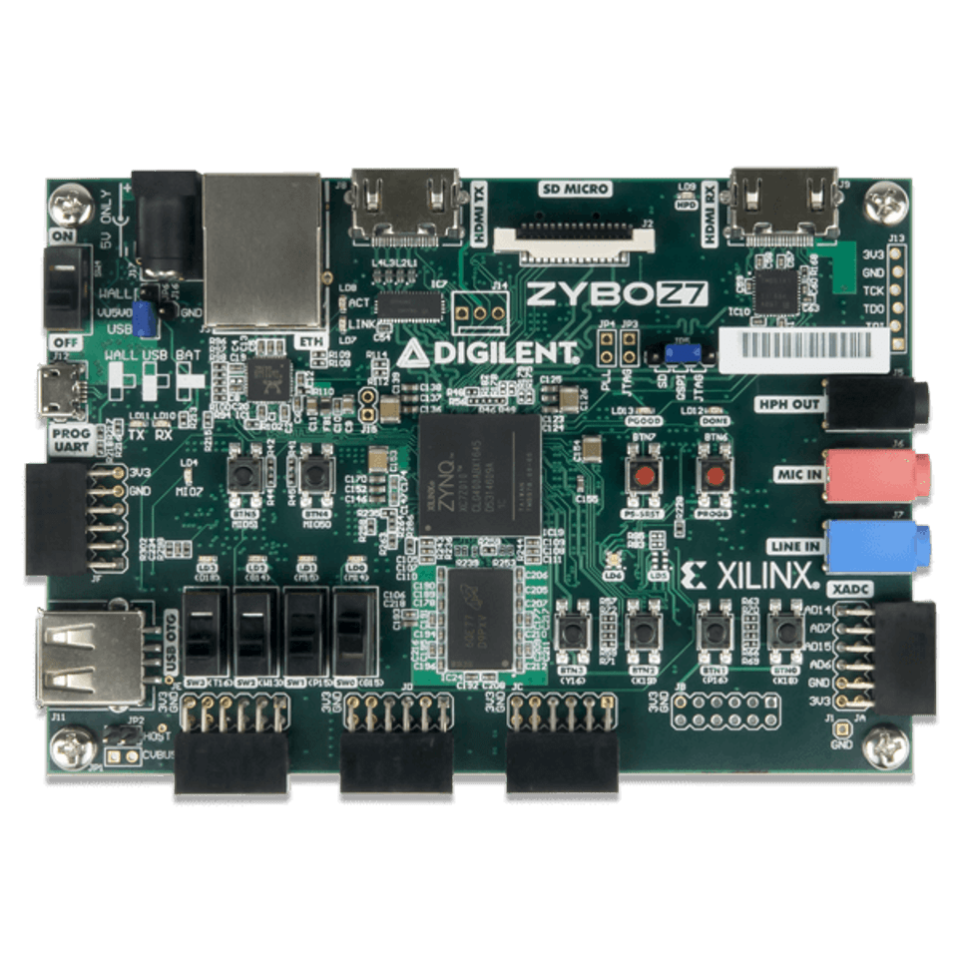

Figure 1.7: The Zybo Z7-10 board [3]

## 1.4 Implementation

This project will have the image processing done through MATLAB. The inputs and the binary mask for the parking lot and cars will be recorded into a text file pixel by pixel so it can be streamed through the VGA. For the Xilinx part of the project, we will implement a block design to use the VGA to display our result from MATLAB, and we will use the switch to compare the masks to relate to the original image whether there is a car parked in the parking space or not.

# MATLAB Implementation

## 2.1 Setup

To initiate this project, three specific images are required. The first image depicts a parking lot filled with vehicles and serves as the reference image from which all cars will be extracted. Figure 2.1 shows the occupied parking lot used in this project.

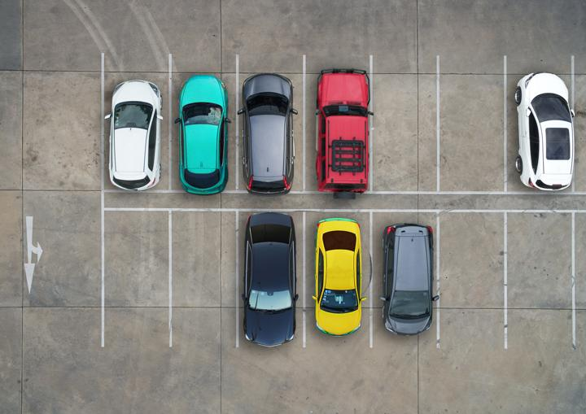

Figure 2.1: Filled parking lot with cars [4]

The second image consists of the same parking lot but with no cars in it, which was created through Photoshop. This second image will be used to help us extract the cars from the image with the filled parking lot. Figure 2.2 shows the empty parking lot image we use for this project.

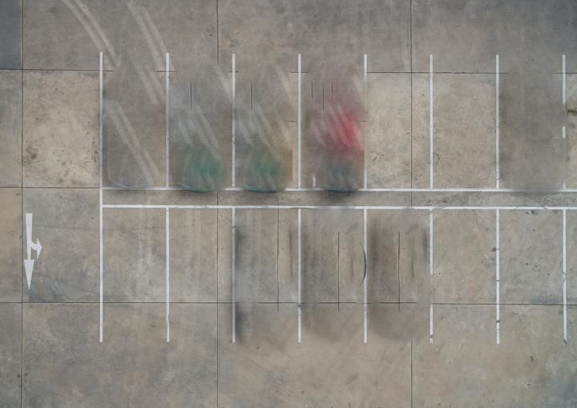

Figure 2.2: Empty parking lot

The final image serves as the mask for the parking lot. It consists of the same parking lot scene, but with white rectangles placed over each parking space. These rectangles were manually added by editing the empty parking lot image using Photoshop. This step was performed to allow the extraction of each parking space and to obtain the coordinates of each parking spot in the image. Figure 2.3 shows the parking lot mask used in this project.

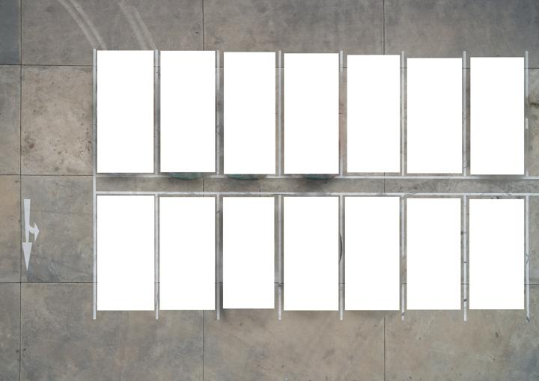

Figure 2.3: parking lot Mask

These 3 images are then loaded into MATLAB using the “imread” function. This defines each image as an unsigned 8-bit 3-dimensional matrix. Figure 2.4 illustrates how an RGB image is defined in MATLAB

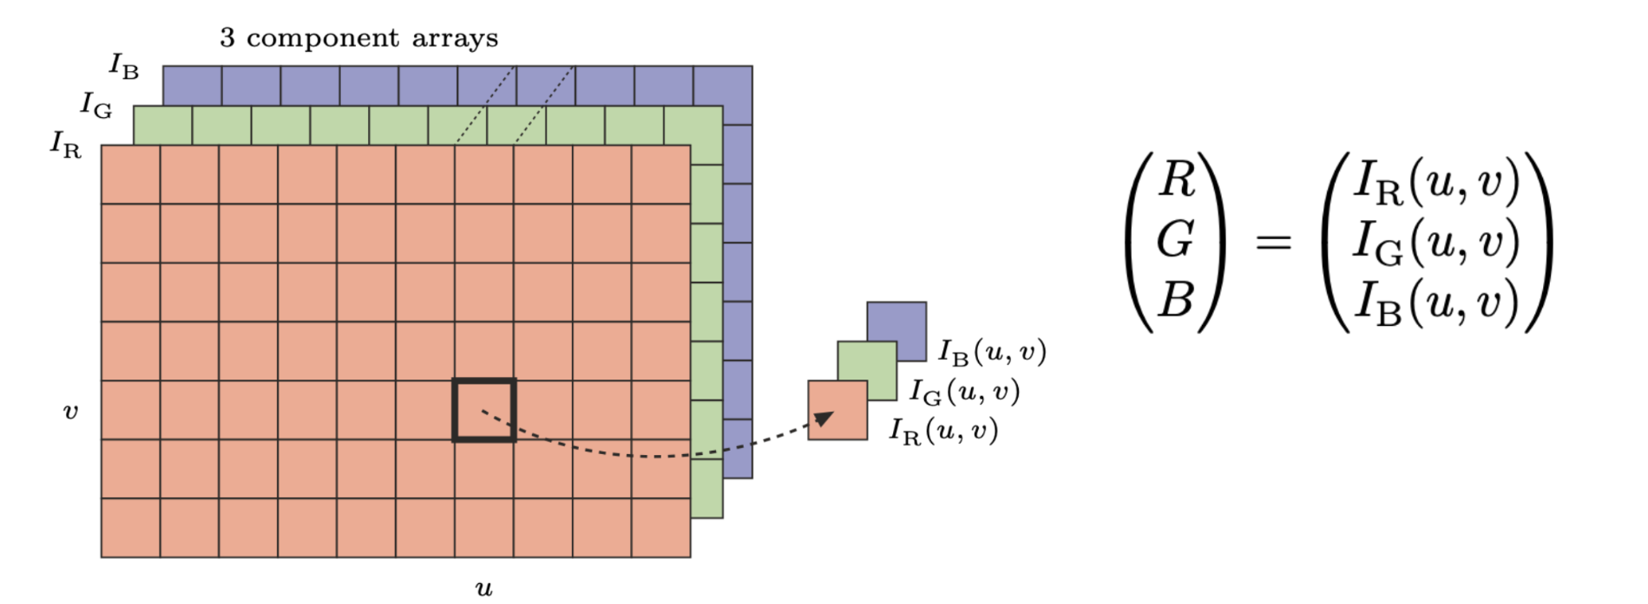

Figure 2.4: RGB image channel in MATLAB [1]

## 2.2 Getting the Binary Parking Lot Mask

The binary parking lot image will allow us to have a mask for every parking spot that allows us to access all of them. To get this mask, the first step to achieving this mask is to max out the parking lot mask from figure 2.3 to 255. This will make it so every pixel that doesn’t have a pixel intensity of 255 in all 3 channels will go straight to 0, while pixels with an intensity of 255 in all 3 channels go to 1. Figure 2.5 shows the parking lot mask after applying max to it.

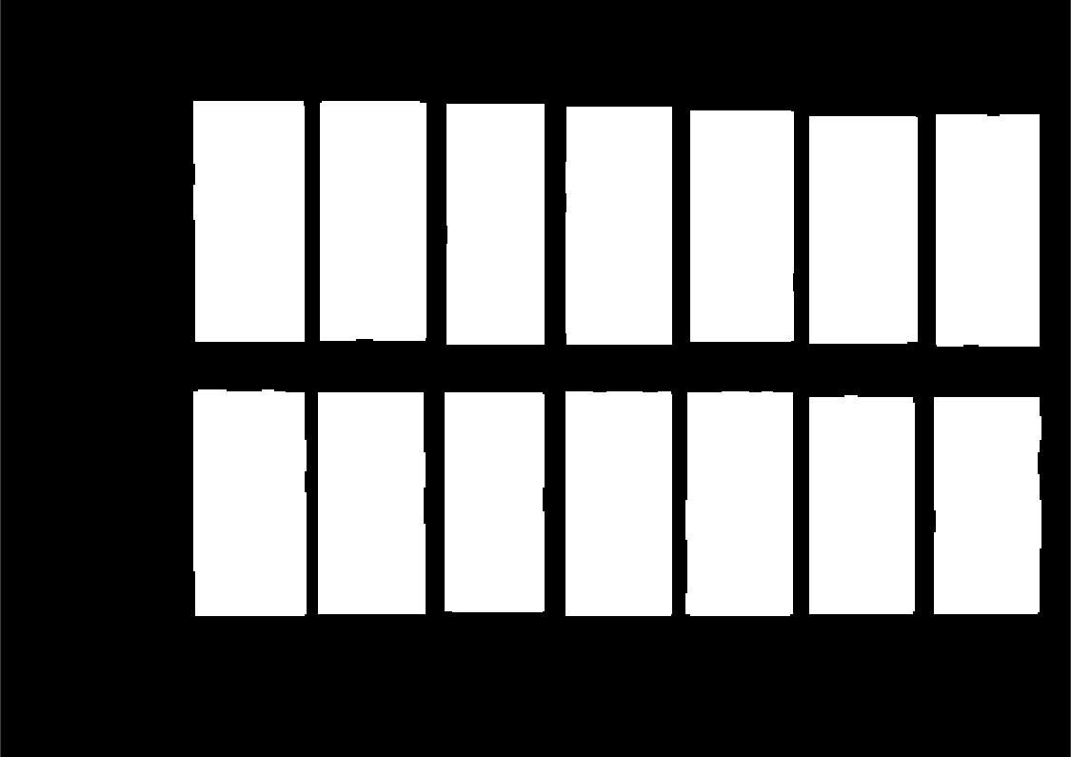

Figure 2.5: Parking mask after maxing it

After getting the binary parking mask, we use the bounding box function in MATLAB to extract the coordinates of the centroid of every parking space that’s in the binary mask, so we will now have access to every parking lot location in the image. Figure 2.6 shows the coordinates extracted from the binary parking mask.

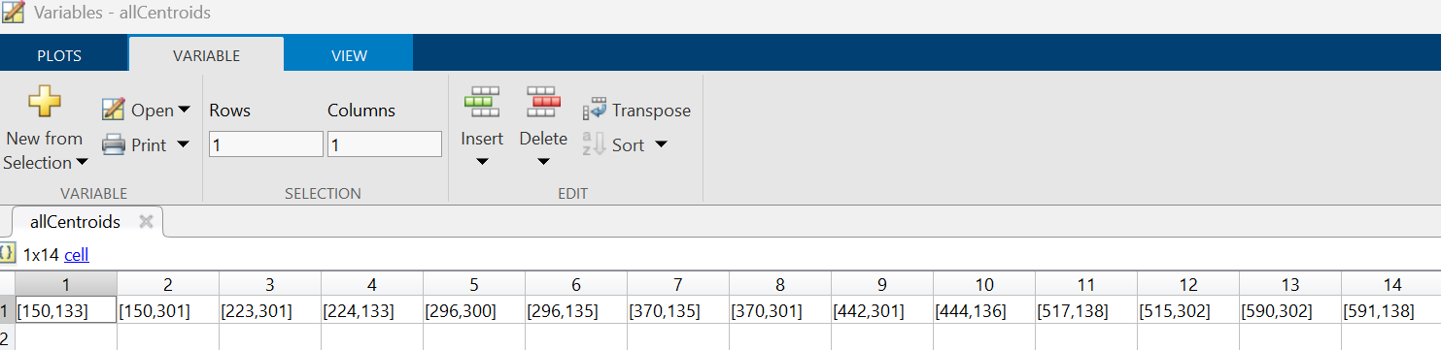

Figure 2.6: Extracted coordinates of every parking lot space in the image.

## 2.3 Getting the binary car mask

The process of obtaining a binary mask of the cars required several image processing techniques to effectively extract the vehicles from the original image shown in Figure 2.1. Figure 2.7 presents a flowchart illustrating the overall procedure used to extract the cars from the original image.

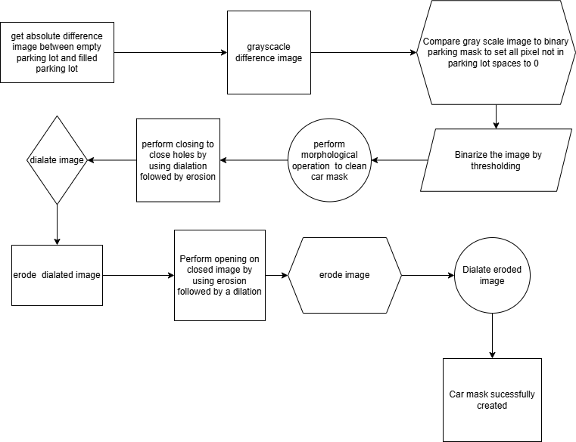

Figure 2.7: Flowchart on extracting cars from the original image.

As seen in Figure 2.7 the first step to extracting the car is to get the absolute difference between filled parking lot image and the empty parking lot image. Doing this will allow us to completely segment the cars while getting rid of the background. Figure 2.8 shows the result of getting the image difference.

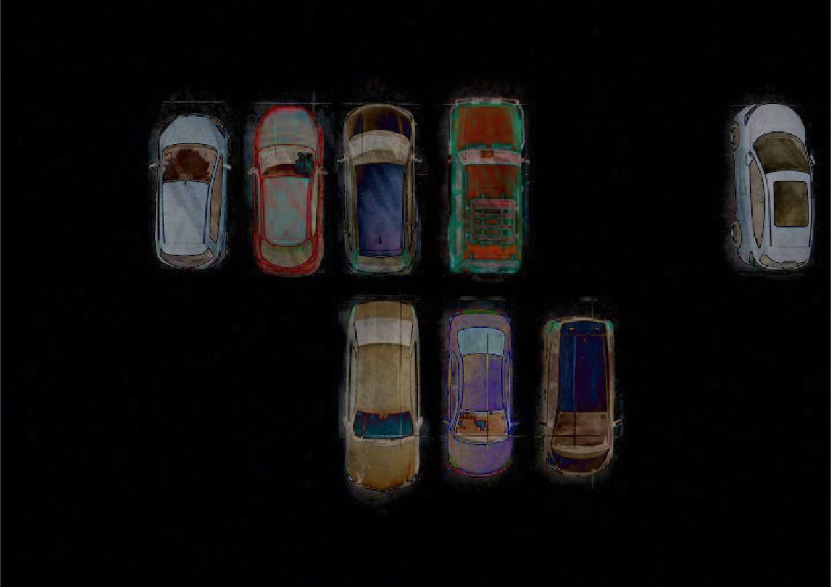

Figure 2.8: Difference image result between the filled parking lot and the empty parking lot

After obtaining the difference image, the result shown in Figure 2.8 is converted to grayscale and compared with the binary parking mask to eliminate any stray pixels that are not in parking lot regions. Figure 2.9 presents the resulting grayscale difference image.

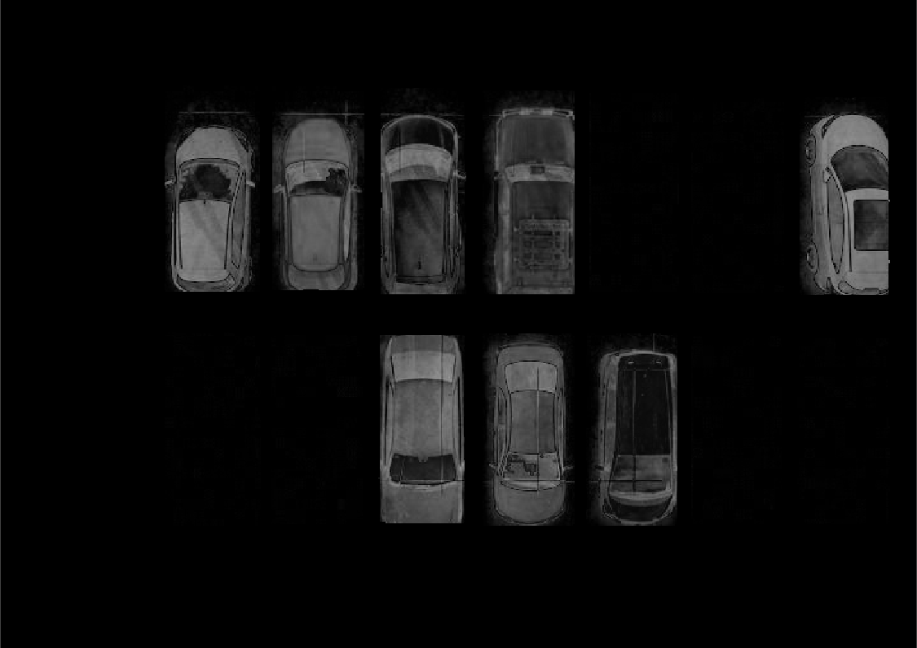

Figure 2.9: Gray scaled cars

The next step is to threshold the gray scaled image so that morphological operations can be performed on the binary mask to clean it up. When applying a threshold to an image, it will compare every pixel one by one and make the pixel logical. If the pixel is greater than the threshold, it will have an intensity value of 1. If it is less than the threshold, pixel intensity will go to zero. For this mask, a threshold value of 16 will be applied to the image. While we could use Otsu’s method to find an optimal threshold, it is ultimately not efficient for this project due to the goal of creating a car mask. For this reason, manually thresholding the image is more efficient for creating a mask. Figure 2.10 shows the result after applying the threshold to the image.

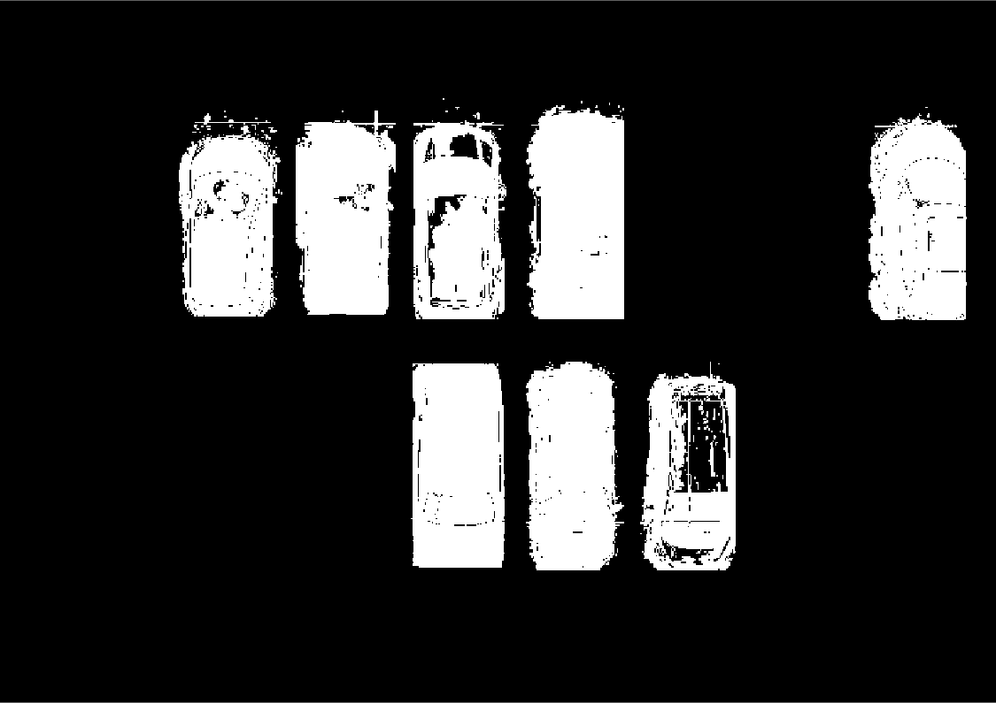

Figure 2.10: Car mask after applying a threshold of 16

The final step in generating a clean car mask for this project involves performing morphological operations on the current binary image. Specifically, a closing operation is first applied to fill in any holes within the objects, The closing involves performing a dilation on the image, followed by an erosion right afterwards on the dilated image. The opening operation is applied to the closed image to separate any connected components that may have been unintentionally merged during the closing process. The process for opening is the opposite of closing, performing erosion first and then dilation. A SE of size 25×10 is used for both operations.

When applying morphological operations such as opening or closing, which involve erosion and dilation, the first step is to create a duplicate of the image and apply zero-padding. The size of the zero-padding is determined based on the dimensions of the SE, ensuring that the operation can be applied to the edges of the image without running into the issue of going over the boundary of the image. Figure 2.11 shows an example of an image with zero padding.

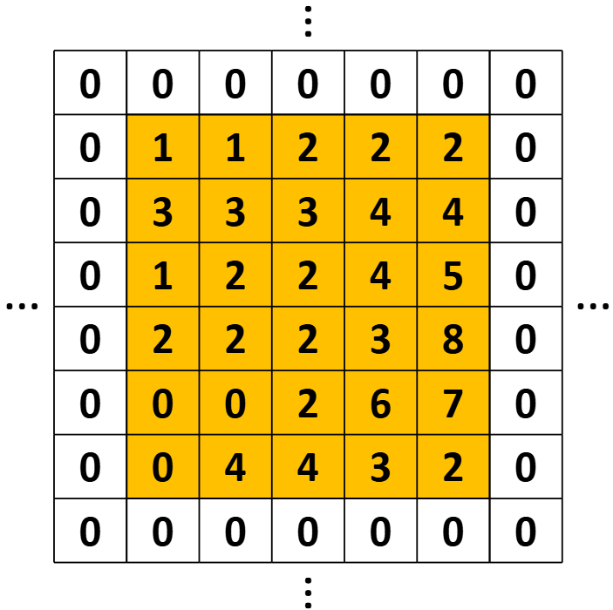

Figure 2.11: Sample of zero padding being applied to an image in matrix form [1]

After the closing is applied to the binary image, we get the results that are in Figure 1.5. As seen in that image, some of the cars got fused and need to have an opening performed to separate them. After performing the opening, we get the result in Figure 1.6, which is our cleaned-up car mask.

## 2.4 Detecting cars in MATLAB

Now that both the car mask and the parking lot mask have been generated, they can be utilized to determine whether a car is present in the original image. By using the centroid coordinates obtained during the creation of the parking lot mask, the two masks can be compared at each centroid location. If the pixel intensities match at a given parking spot, it can be concluded that a car is present. Conversely, if the pixel intensities differ, the parking spot is considered unoccupied.

Figure 2.12 illustrates the original parking image with detected vehicles, based on the comparison of the two binary masks. A red 'X' indicates that a parking spot is occupied, while a green circle denotes that the spot is available. Figure 2.13 presents the same image as Figure 2.12, but with the corresponding centroid coordinates displayed.

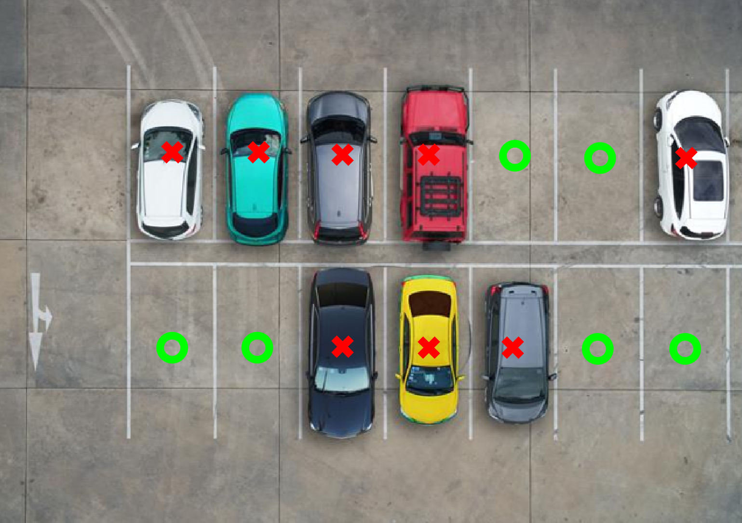

Figure 2.12: Filled parking with detected cars

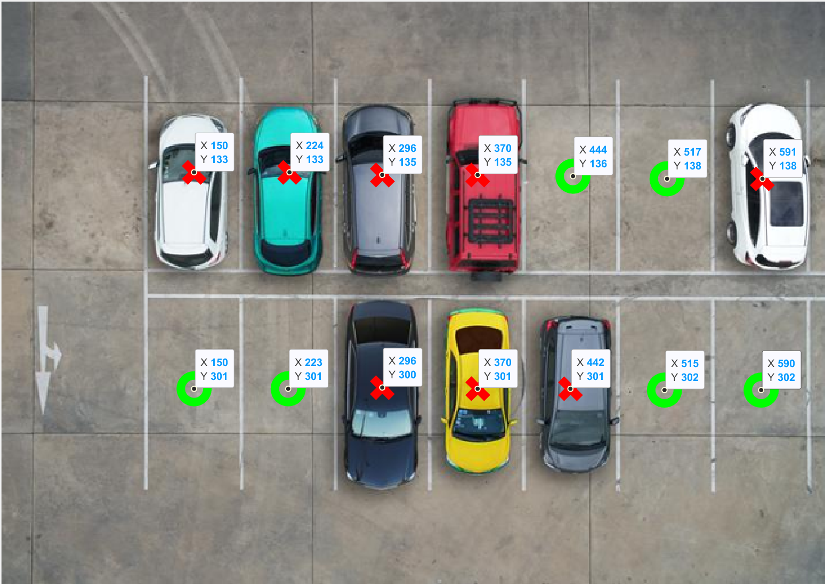

Figure 2.13: Filled parking lot with displayed coordinates

# Hardware

## 3.1 Setup

For the next stage of this project, the hardware setup for the FPGA will be implemented. This part of the project will focus on the PL side of the FPGA. As stated in Section 1.4, the board used for this project is the Zybo Z7-10. A VGA PMOD will also be utilized to stream both the input image and the two binary masks developed in MATLAB. The hardware design will be created using Vivado, and it will include Verilog code for specific IP blocks. Figure 3.1 illustrates the process of creating a Vivado project. Once the project has been created, the appropriate board is selected, as shown in Figure 3.2.

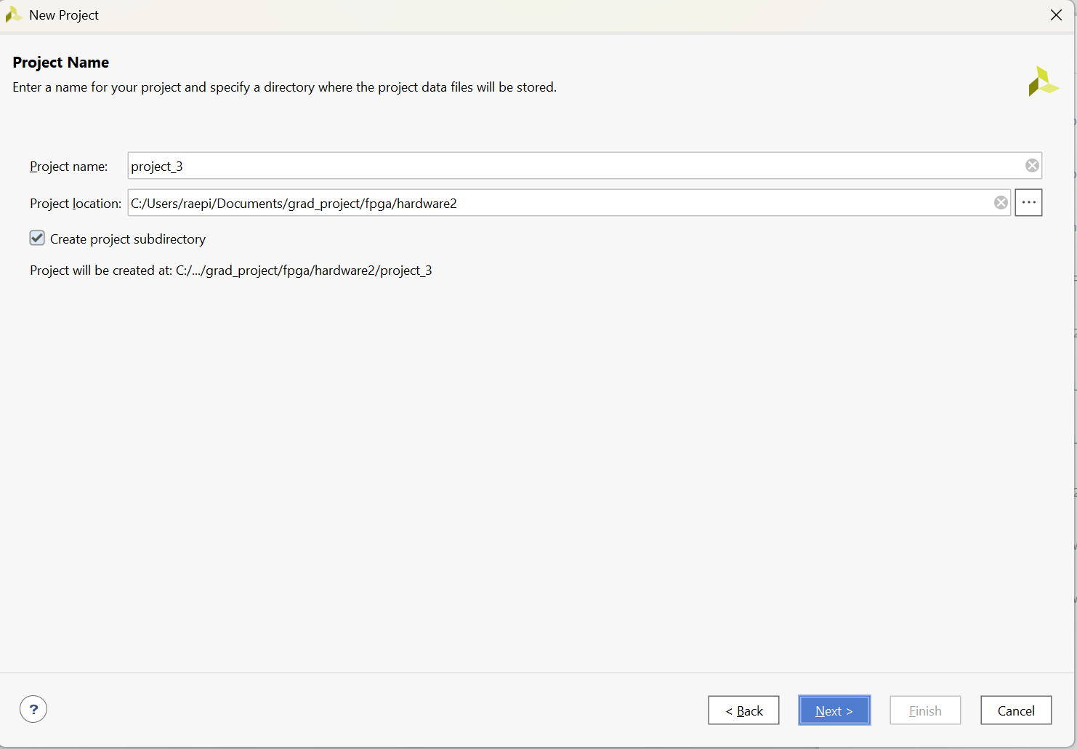

Figure 3.1: Creating project

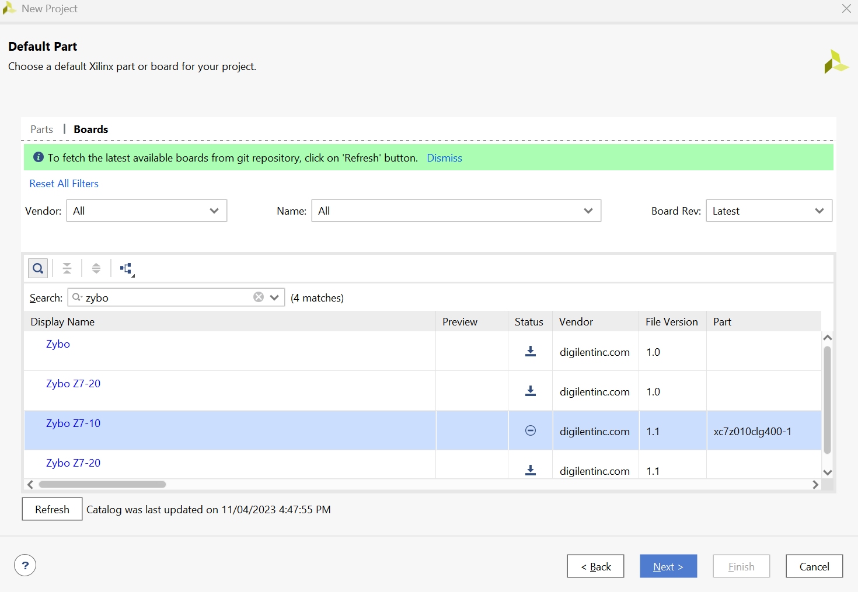

Figure 3.2: Selecting the Zybo Z7-10 board

Figure 3.3 shows the VGA PMOD that will be used for this project. The VGA PMOD has a limitation of taking only up to 4-bits for the RGB channels. So, images that have 8-bit pixels should be logically shifted to the left by 4 to normalize the pixel to 4-bits.

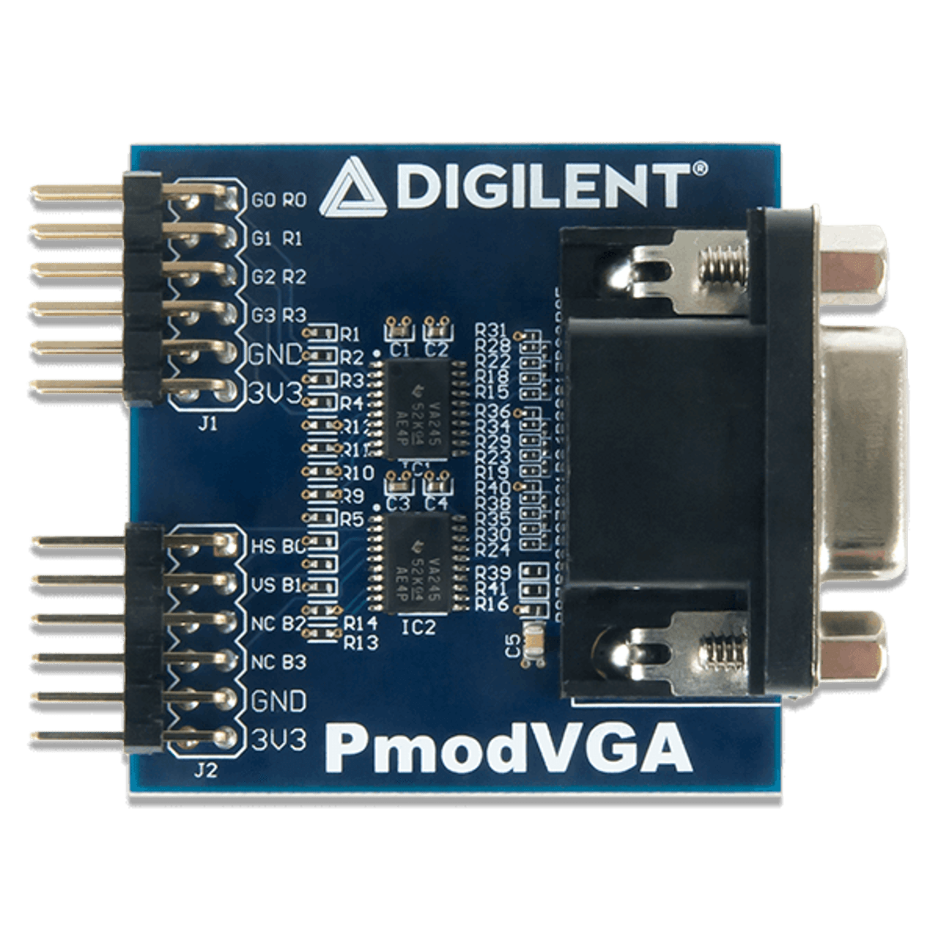

Figure 3.3 VGA PMOD [5]

## 3.2 Creating Block design for Hardware

Now that the Vivado project has been set up. We can now begin creating our block design for our hardware required for this project. Figure 3.4 illustrates the completed block design, which consists of a combination of hard and soft IP cores. Hard IP cores, such as the Zynq Processing System, are hardwired into the silicon of the chip and cannot be customized. Soft IP cores, on the other hand, such as the VDMA, Video Timing Controller, Clocking Wizard, and AXI4-Stream to Video Out are synthesized within the FPGA fabric and can be customized as needed.

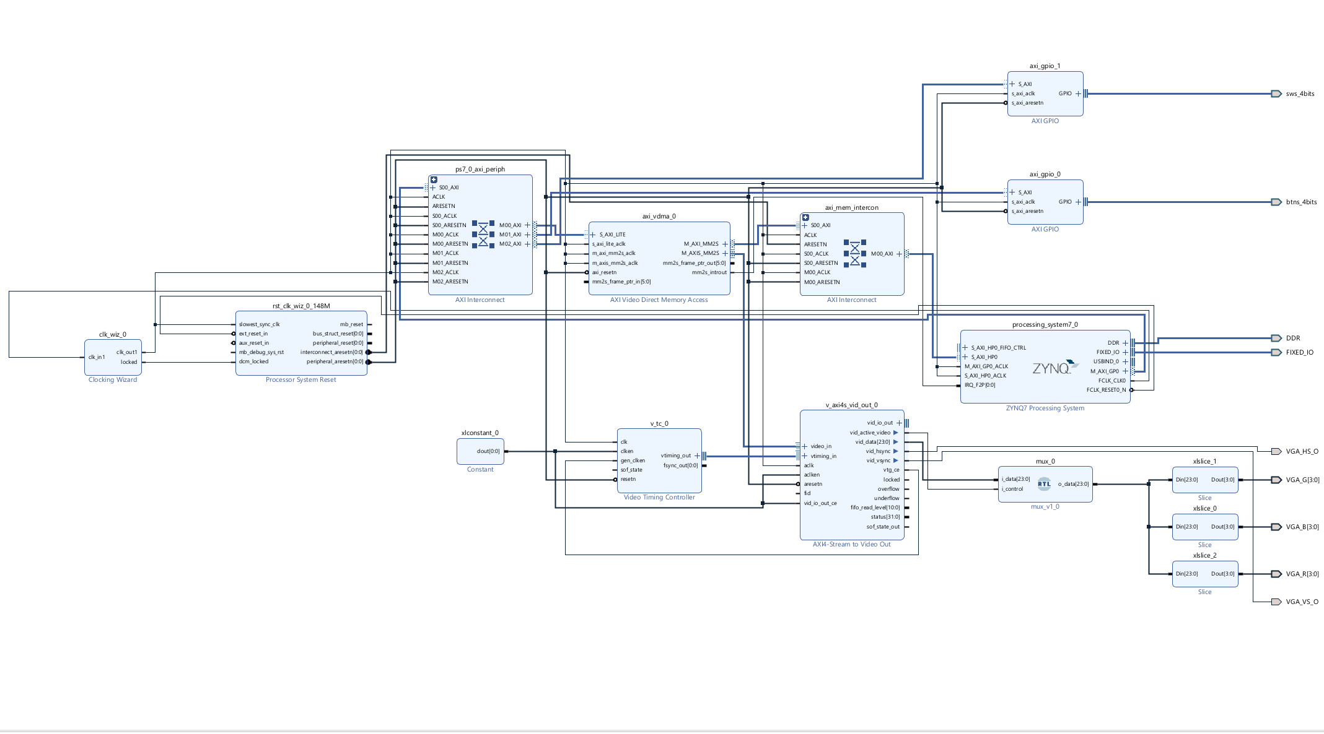

Figure 3.4: Full block design used for this project

### 3.2.1 Zynq processing system

The Zynq processing system IP block, as shown in Figure 3.5 is an important IP block in any block design as it represents the Arm Cortex-A9 processor subsystem embedded in the Zynq chip. It grants access to the processor along with its peripherals.

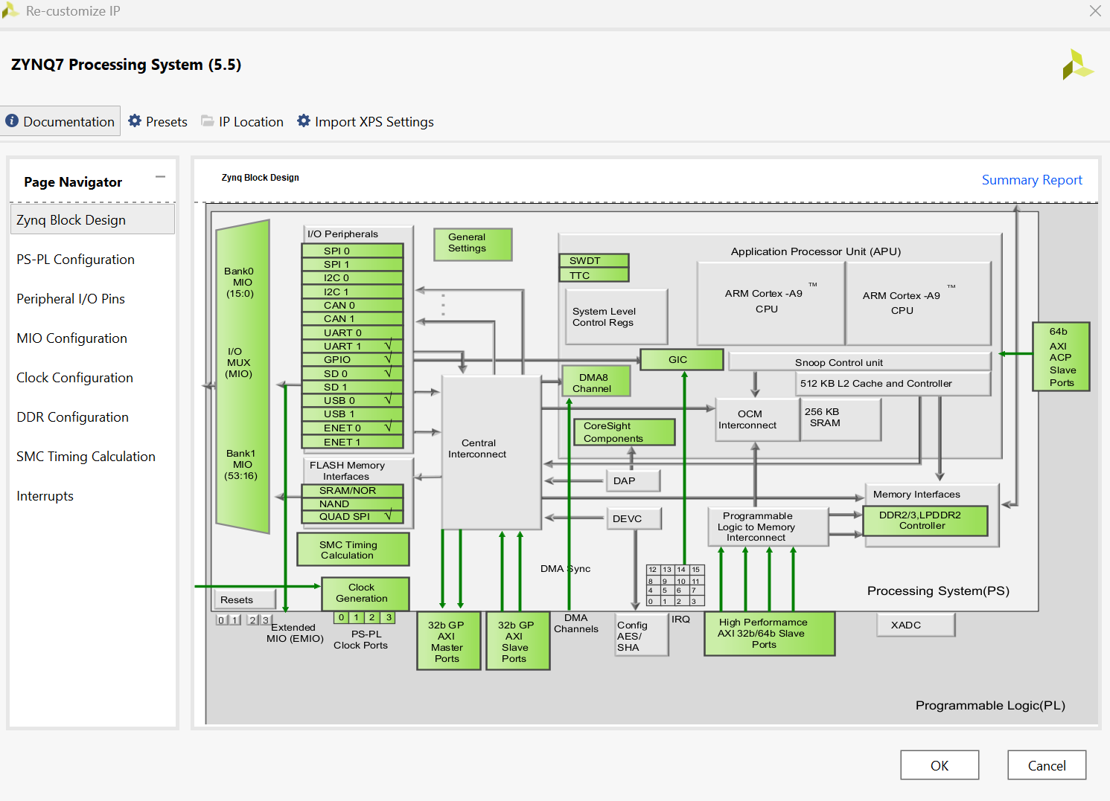

Figure 3.5: Zynq processor subsystem

### 3.2.2 Video Interface

The video interface portion of the hardware design is responsible for displaying images on a monitor. Since all image data will be streamed at 1080p resolution, it is necessary to increase the clock frequency. The Zybo Z7-10 board provides an external clock of 125MHz to the PL. The VGA supports up to 150MHz. To maximize the VGA performance the clocking wizard is utilized to increase frequency. This clock is routed to a Clocking Wizard IP core, which increases the frequency from the initial 125 MHz to an improved frequency of 148.5 MHz. Figure 3.6 shows how the Zynq Processing System provides the clock signal to the Clocking Wizard and is increased to a more desirable 148.5 MHz.

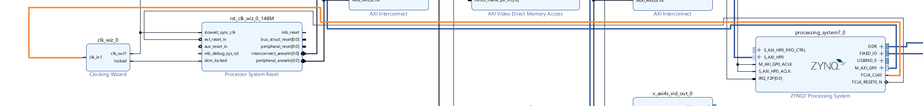

Figure 3.6: Zynq processor clock path to clocking wizard

After setting up the clocking wizard, the AXI4S to Video Out is set up so it can transmit video data input as shown in Figure 3.7. A video timing controller IP is then implemented to provide the necessary timing control, which includes the horizontal sync and the vertical sync to the AXI4s to Video out as shown in Figure 3.8.

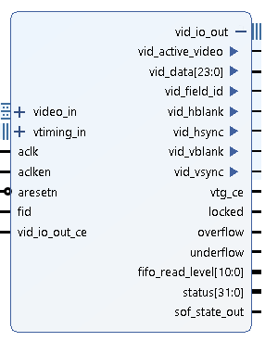

Figure 3.7: AXI4S to Video Out IP block

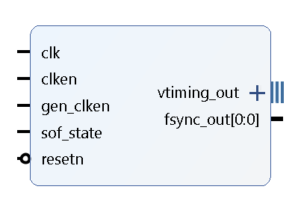

Figure 3.8: Video timing controller IP block

The video data and the control signal are then sent to a mux. The mux then outs the 24-bit color pixel data that is then divided into the RGB signals. Due to the limitation of the VGA PMOD only supporting 4-bit pixels from each channel, we use a slice to reduce each channel from 24 bits to 4-bits instead of 8-bits due to the limitation of the VGA PMOD, as seen in Figure 3.9. Figure 3.10 shows how we connected the VGA PMOD pins to the FPGA board in the block diagram.

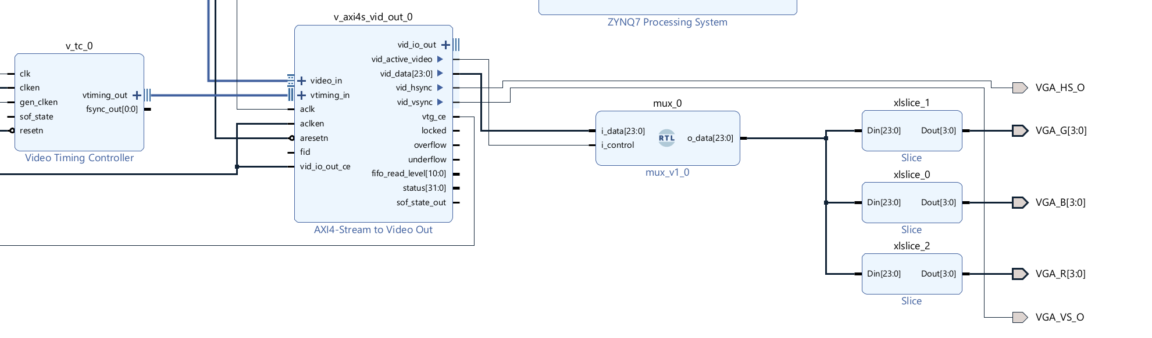

Figure 3.9: Video processing system IP design

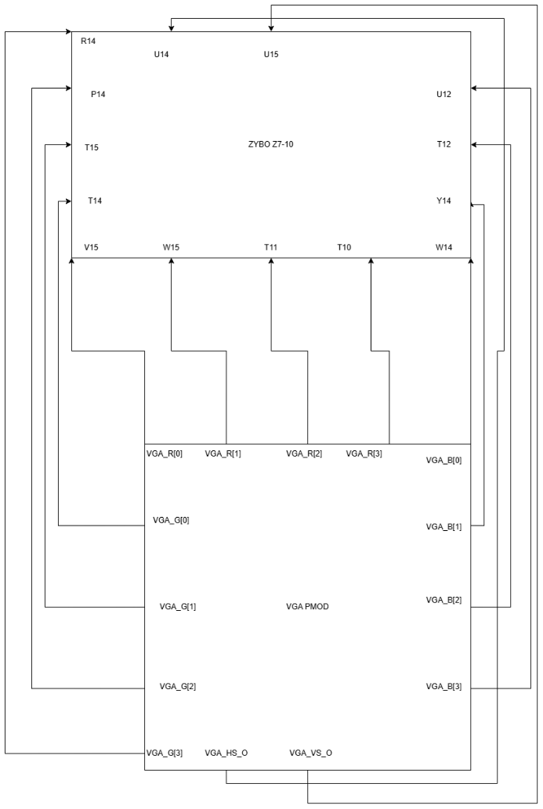

Figure 3.10: Pin mapping from the VGA PMOD to the Zybo

Lastly, we implement a VDMA to handle to video data as shown in Figure 3.11. The VDMA is compatible with the AXI4S to Video Out IP block. By using VDMA we have higher bandwidth direct memory access. Figure 3.12 shows a block diagram of how VDMA sends the video through the system.

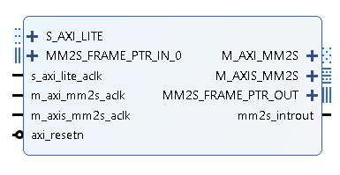

Figure 3.11: VDMA IP block

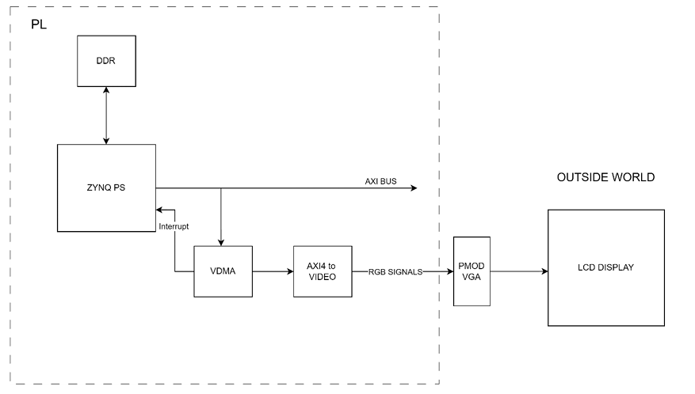

Figure 3.12: VDMA processing data path [6]

The VDMA will also utilize two buffers for this project in order to effectively transition between images without having screen tearing. Screen tearing is a result of only using one buffer to read and write to memory at the same time. By having two buffer that read and write to memory separately this will eliminate the screen tear issue and improve the overall performance of this project. Figure 3.13 and 3.14 shows the read and write pathway for single buffer and double buffer.

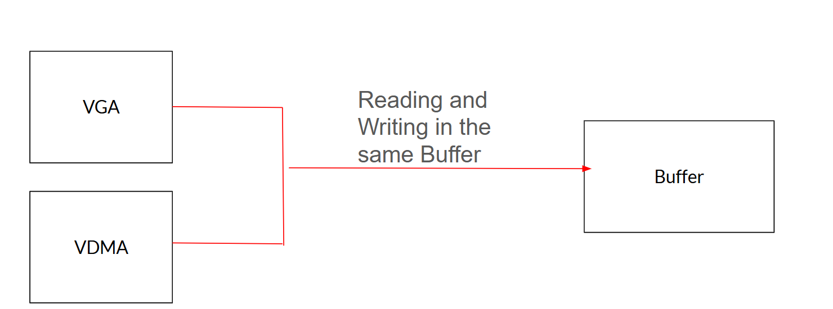

Figure 3.13: Read and write pathway for single buffer

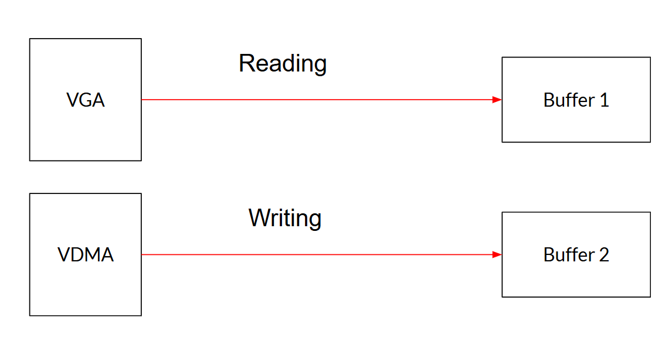

Figure 3.14: Read and write pathway for double buffer

### 3.2.3 GPIO

GPIO are digital pin used to read input and control the output signals. In Vivado there is an AXI GPIO IP block that allows us to enable us the following:

* 4-bit push buttons
* HDMI in hpd led
* HDMI out hpd led
* 4-bit led
* RGB led
* 4-bit switches

For the is project, we will use 2 GPIO that will consist of the 4-bit pushbutton and the 4-bit switches as seen in Figure 3.15. The pushbutton will be responsible for letting us display a different image. The switches will be responsible for letting us evaluate a certain parking lot we choose.

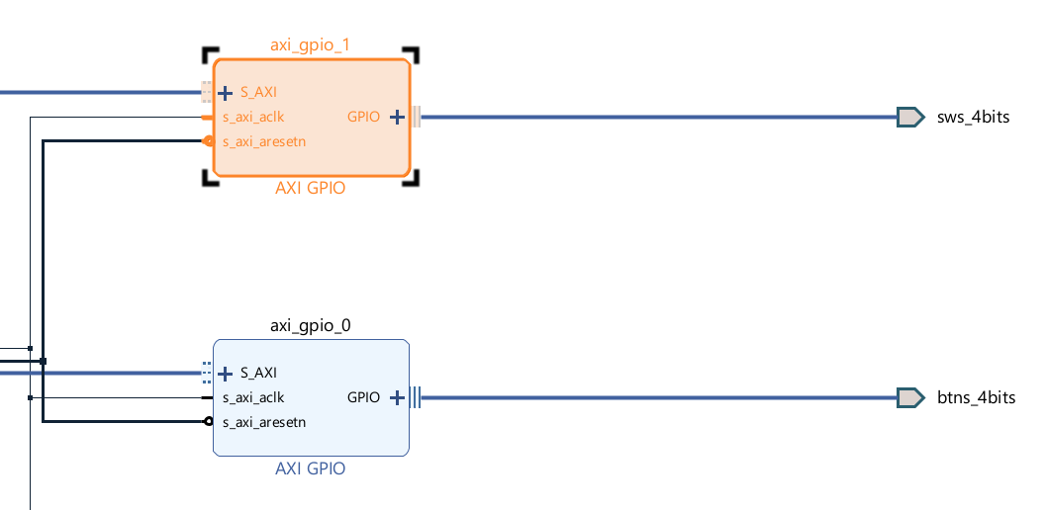

Figure 3.15: GPIO IP block for the switches and push buttons.

## 3.3 Generating bitstream

After completing the block design, we must generate the bitstream in order to export it into Vitis. Before generating the bit stream, the block design must be validated. As seen in Figure 3.10, the ports for the VGA must be mapped to ports in the FPGA, failure to do so will result in an invalid design. Once the design is validated, synthesis is then performed and the bitstream starts generating. Once the bitstream is generated, the elaborated design and the implemented design are available as seen in Figure 3.16 and 3.17. With the bitstream generated, it is now ready to be exported into Vitis.

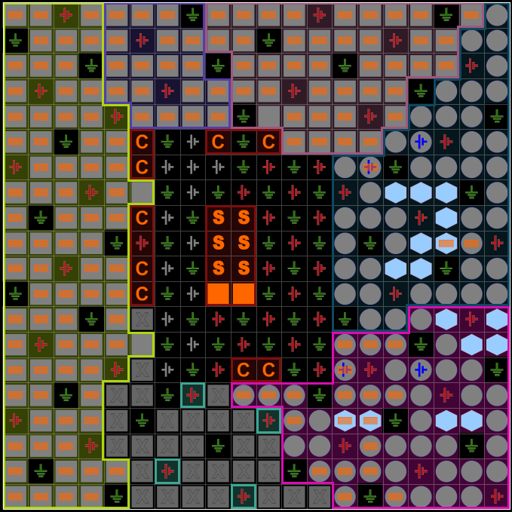

Figure 3.16: Elaborated Design

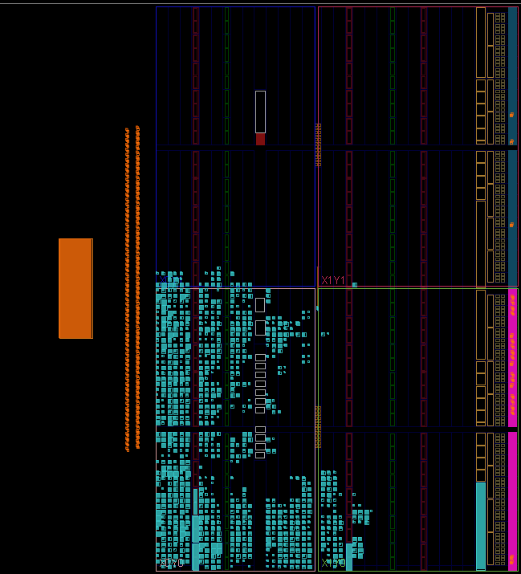

Figure 3.17: Implemented design

# Software Design

## 4.1 Setup

For this final part of the project, after exporting the bitstream created in chapter 3, it is imported into Vitis. Unlike the hardware development in Chapter 3, this chapter will focus on using the PS side of the FPGA. Figure 4.1 and 4.2 shows how to start the project and Vitis and select the bitstream created from the hardware in Chapter 3.

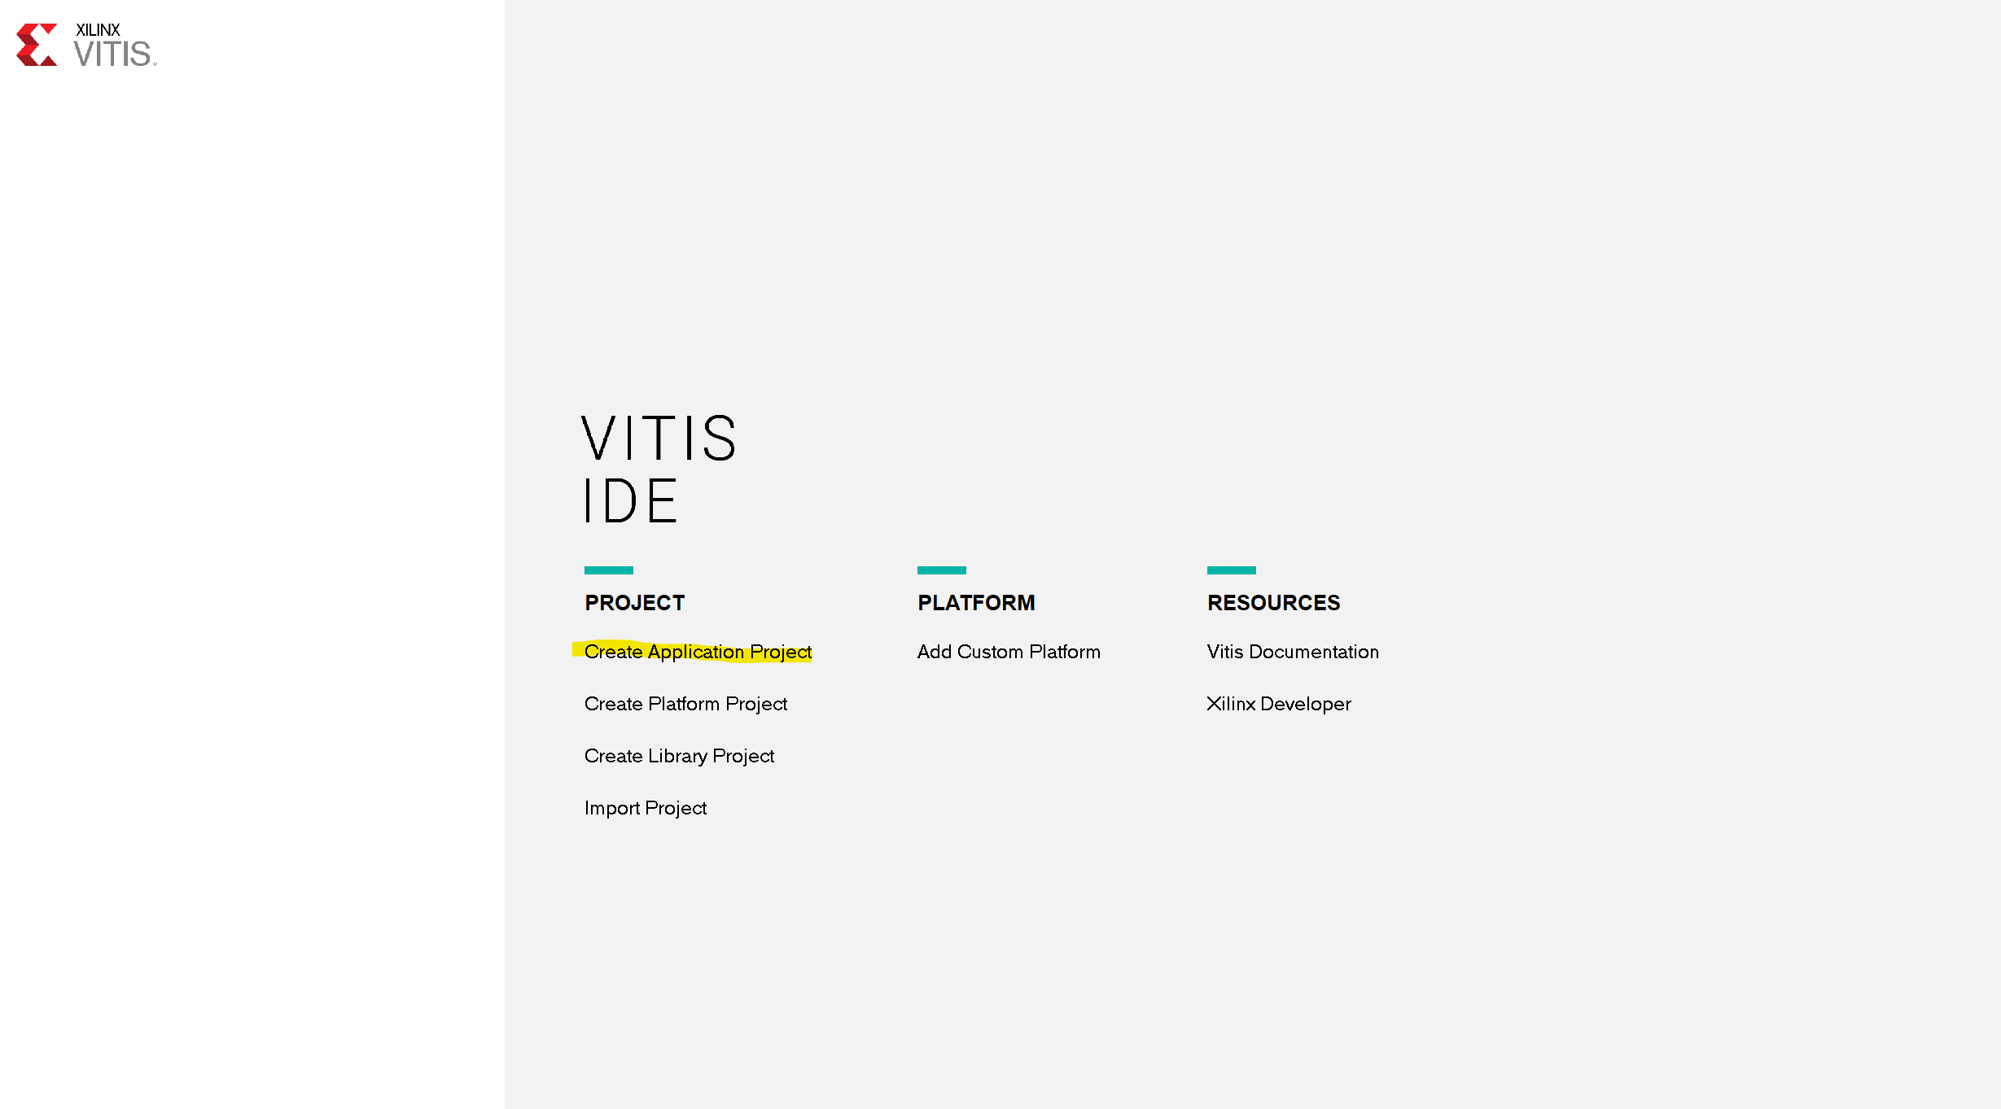

Figure 4.1: Creating a project in Vitis

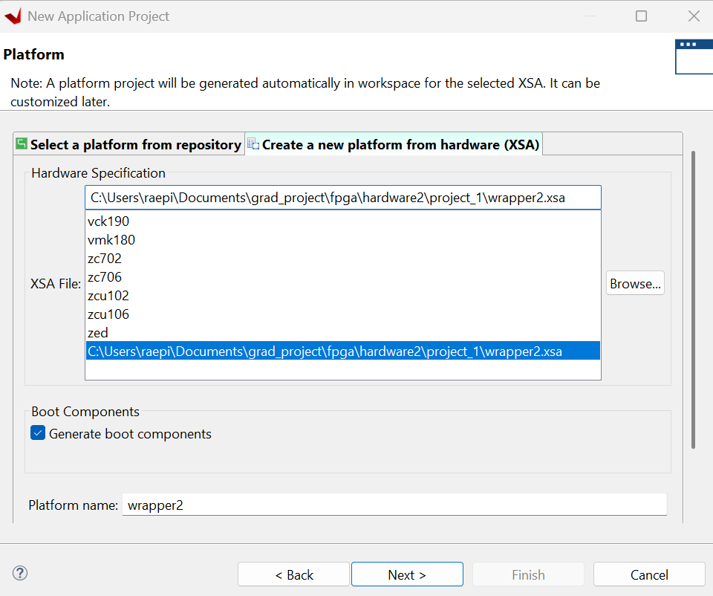

Figure 4.2: Selecting wrapper that contain bitstream

After loading the bitstream into the project, the content of the bitstream become available in the header file “xparameter.h”. In that header file it has all the hardware block that we designed in chapter 3 such as the Zynq processor for the Zybo Z7-10, GPIO for the button and switches, and the VDMA as seen in Figure 4.3 and 4.4

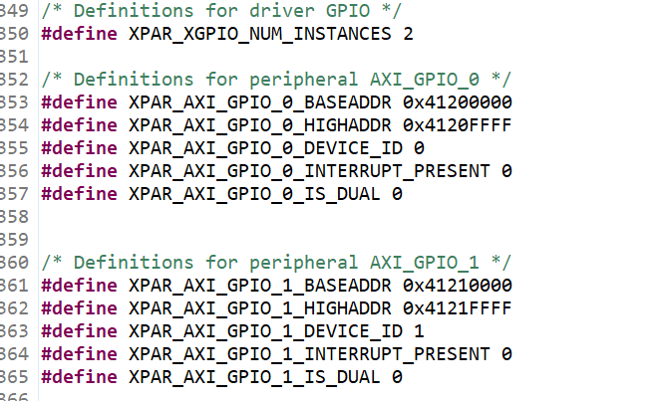

Figure 4.3: Exported GPIO defined for push button and switches

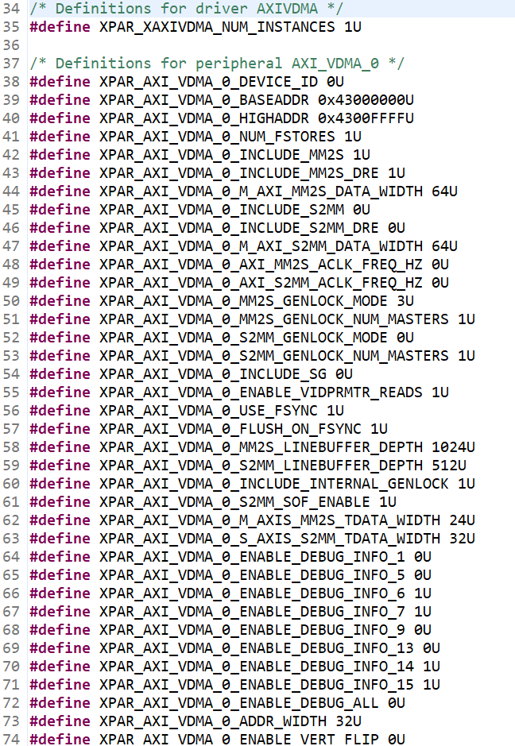

Figure 4.4: Exported VDMA defined

In addition, another header file was created to store the raw data of the parking lot image and the 2 binary masks. A simple MATLAB script was used to write the raw data into a text file to be read in Vitis. The binary mask was normalized back into an unsigned 8-bit data type to keep the data from changing. It was multiplied by 255 to completely normalize the mask for the VGA to display as seen in Figure 4.5. For the original parking image, since it’s a colored image, it was stored in a special way to deal with the RGB channel. The red, green, and blue pixels were stored in a single hexadecimal number so they can be stored as a single element in an array, like a grayscale or binary pixel. Using the format back in Figure 1.1 as an inspiration, the red pixel is stored in the upper 8 bits, the green pixel is stored in the 8 middle bits, and the blue pixel is stored in the 8 lower bits, as seen in Figure 4.5. Doing this will allow us to have a colored image have the same number of elements as a grayscale or binary image.**

Figure 4.5: Raw data of the car mask and parking mask

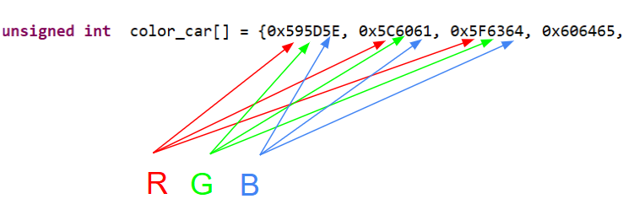

Figure 4.6: Raw data of the colored car original input image

## 4.2 Software algorithm

In Vitis, the primary programming language we use to program the PS side of the FPGA will be the C language. At the beginning of the program, our VDMA and our GPIO are initialized. The centroid data of the parking lot, as seen back in Figure 2.7 and 2.14 is defined in an array. The x and y coordinates are used for an allotted parking. As seen in the original parking image in Figure 2.1, the 1st row of parking spots will be parking lots from left to right 1 through 7, the 2nd row will be parking lots 8 through 14.

After everything is defined, the program will enter an embedded loop. An embedded loop is a loop that is normally supposed to run forever. This is done so things such as GPIO can be updated in real time. Figure 4.7 shows a block diagram of the algorithm that is ran in the embedded loop.

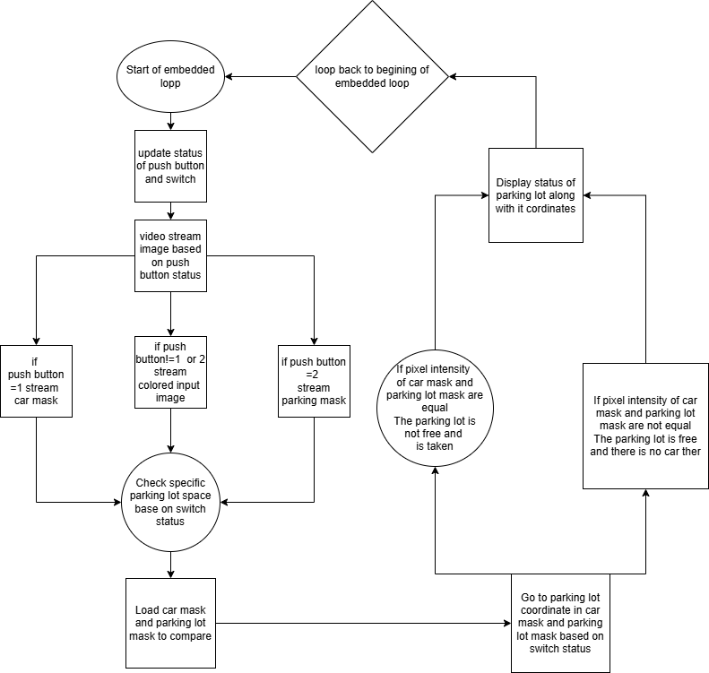

Figure 4.7: Block diagram for the algorithm in the embedded loop

### 4.2.1 Displaying Image

For displaying our images, we use the push button to determine which images get displayed. This project uses two different display functions for this project, as seen in Figure 4.8. The first display function is for colored images, while the other display function is for grayscale and binary images. The reason why we need 2 different functions is due to the data types of the colored image array and the grayscale image array, which pass different data types.



Figure 4.8: Display functions used to display

For the color display function, we pass the width and length of the monitor, the width and length of the image, the vertical and horizontal offset, and finally the address of the image that will be displayed. The offset is used so the image will be displayed in the center of the monitor, as well as assigning any unused part of the monitor with a black pixel. The red, green, and blue pixel values are extracted by using bit mask and performing logical shifts to make sure they are 8-bit pixels. RGB pixels are also then shifted to the right by 4 to make them 4-bit to be normalized to accommodate the limitation of the VGA being able to only display 4-bit pixel per channel. The function for displaying non colored image does the same thing, except the only difference is that the red, green, and blue pixel values are the same as each other due to the image being grayscale/binary.

### 4.2.2 Detecting cars in Xilinx

The switches on the FPGA are used to go to a selected parking lot. Based on the switch value, the program will load a specific coordinate gotten from the centroid data extracted from MATLAB, as seen in Figure 4.9 to go to the chosen parking lot.



Figure 4.9: Centroid data from MATLAB

The parking mask and the car mask are loaded, and we go to those coordinates it evaluates the pixel intensity in them. If they are equal to each other, then a car is detected in that parking space. If the intensities are not equal to each other, then there is no car in that parking lot. Depending on whether a car is detected or not, a small symbol is drawn at the parking lot that is being evaluated. A green circle will be drawn if the parking space is free, while a red x will be drawn if the spot is being occupied by a car.

### 4.2.3 Single Buffering vs Double Buffering

As discussed in chapter 3, We use double buffering as oppose to single buffering to improve the performance of this project. When only using a single buffer, whenever we perform the parking detection or switching what image is being displayed it cause screen tearing to happen which is the result of reading and writing to memory in the same buffer as shown in figure 4.10.When performing parking detection specifically since the buffer is constantly being read and written at the overall parking detection need delay just to see the red X or green circle since it is constantly being over written which slows down the overall parking detection.

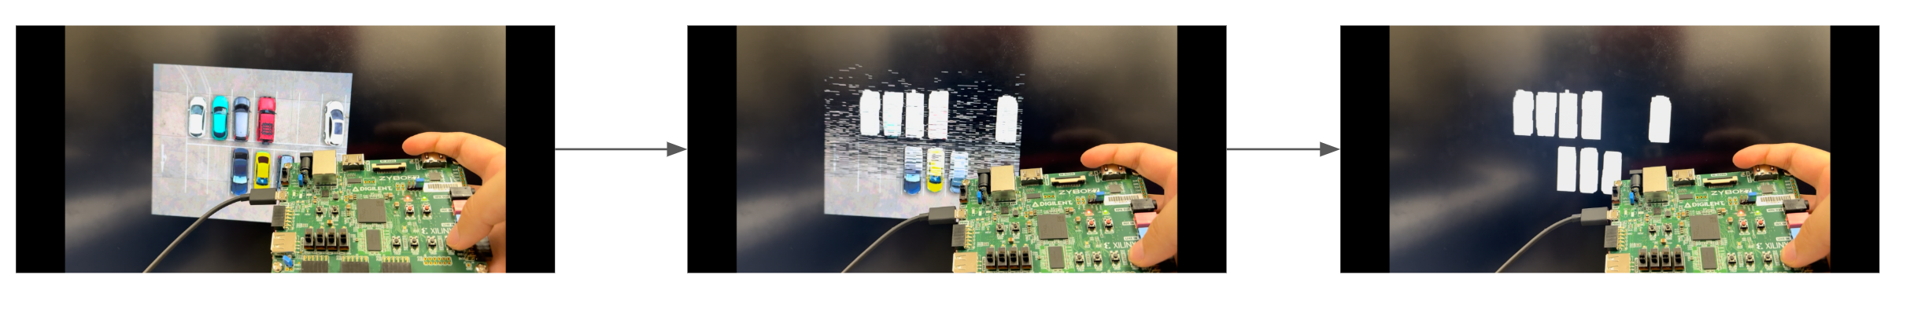

Figure 4.10: Image transitioning having screen tearing from using only a single buffer

By using double buffering, the screen tearing problem is resolved. The buffer is updated whenever we update the GPIO of the push button or switches. When updated it tells the program to start writing to the buffer not currently in use to be prepared for the program to read. Once at the end of an iteration of the embedded loop, the program reads the buffer after everything has been written to it. Figure 4.11 shows images transition from using double buffering. Unlike the single buffer, when using the double buffer delay are not needed when showing the red X or green circle when doing parking detection since reading and writing happens in separate buffers. Since there are no delays now the parking detection is much faster than it was when it was using a single buffer

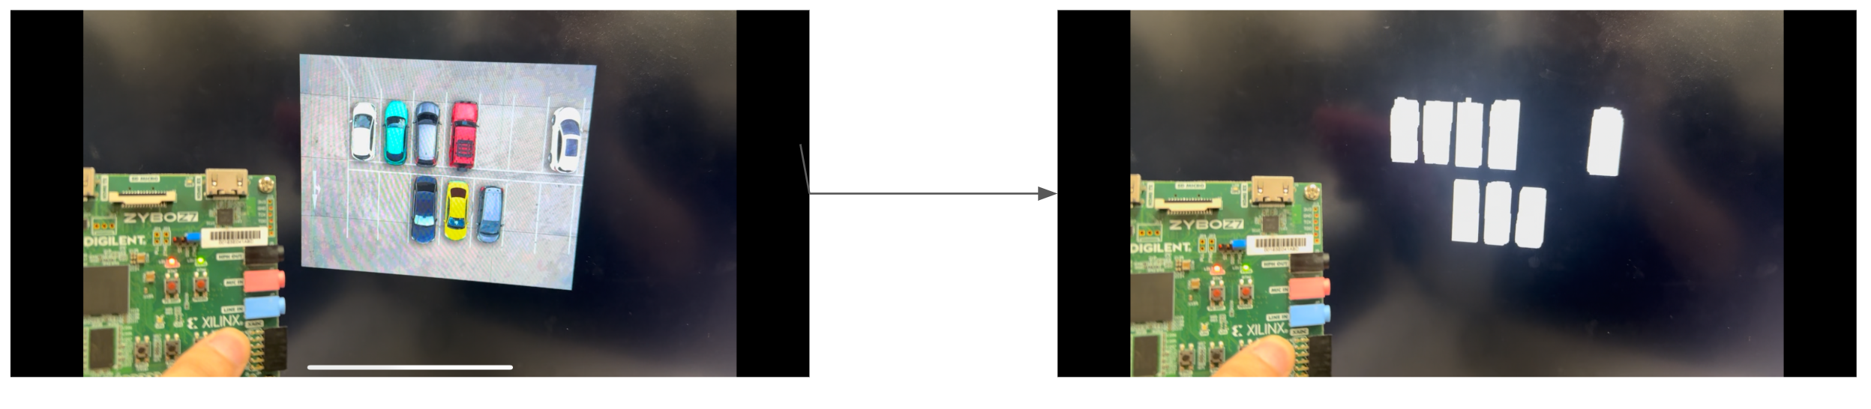

Figure 4.11: Image transitioning with no screen tear through double buffering.

# Results and Conclusion

## 5.1 Equipment Setup

The physical equipment consists of the Zybo Z7-10 FPGA board, VGA PMOD, laptop, and a monitor as seen in figure 5.1, 5.2, and 5.3.

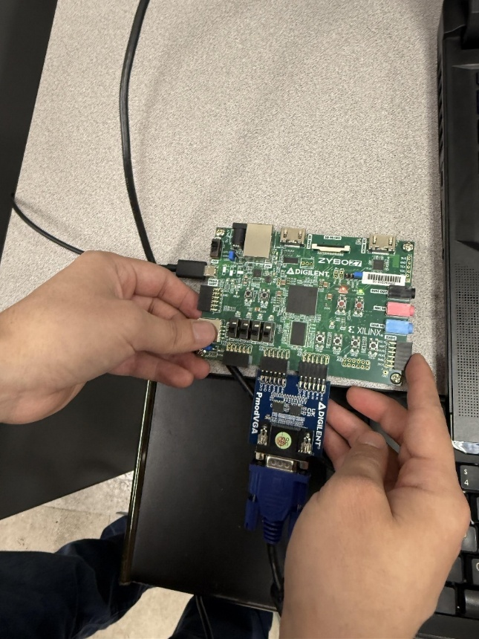

Figure 5.1: FPGA board connected to VGA PMOD

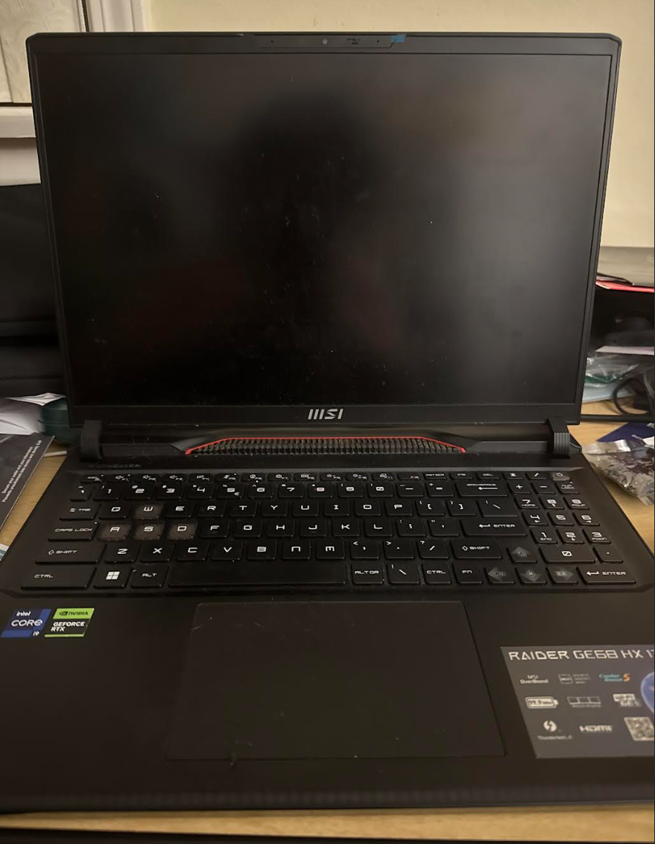

Figure 5.2: Laptop

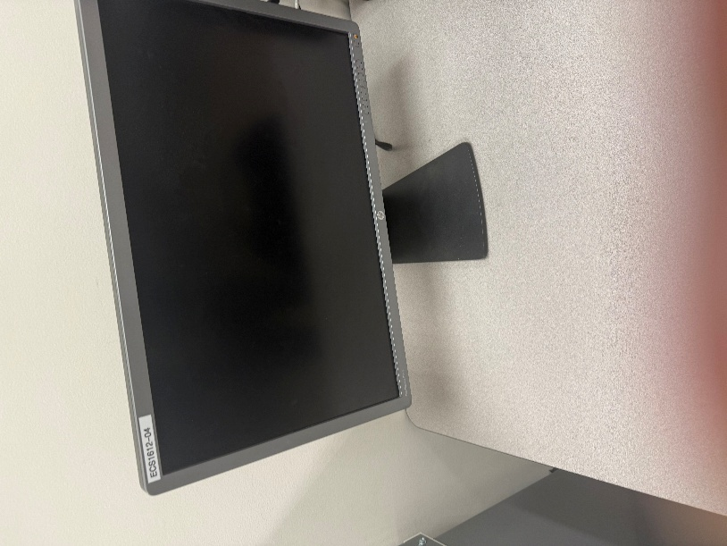

Figure 5.3: Monitor

## 5.2 Simulation

Before programming the FPGA, the project must run build project to make sure there are no errors in the software code. If the build was successful and there were no errors, the FPGA is ready to be programmed as seen in figure 5.4 and figure 5.5.

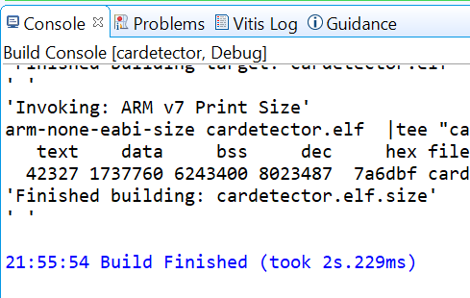

Figure 5.4: Build successful

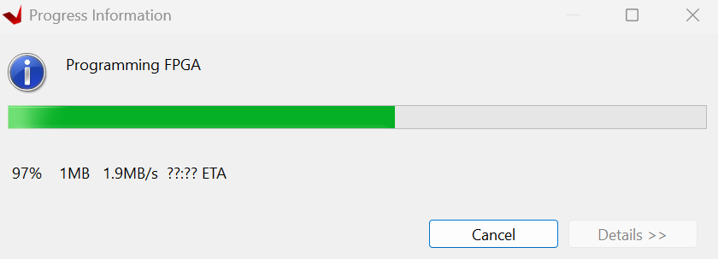

Figure 5.5: FPGA being programmed

## 5.3 Results

With the program now running, the VGA starts video streaming our input image and can change what image it streams based on the push button status as seen in figures 5.6,5.7, and 5.9.

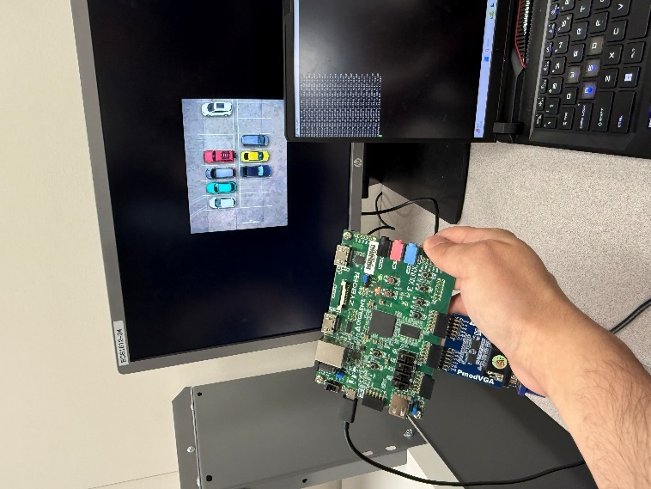

Figure 5.6: Displaying the colored parking lot image

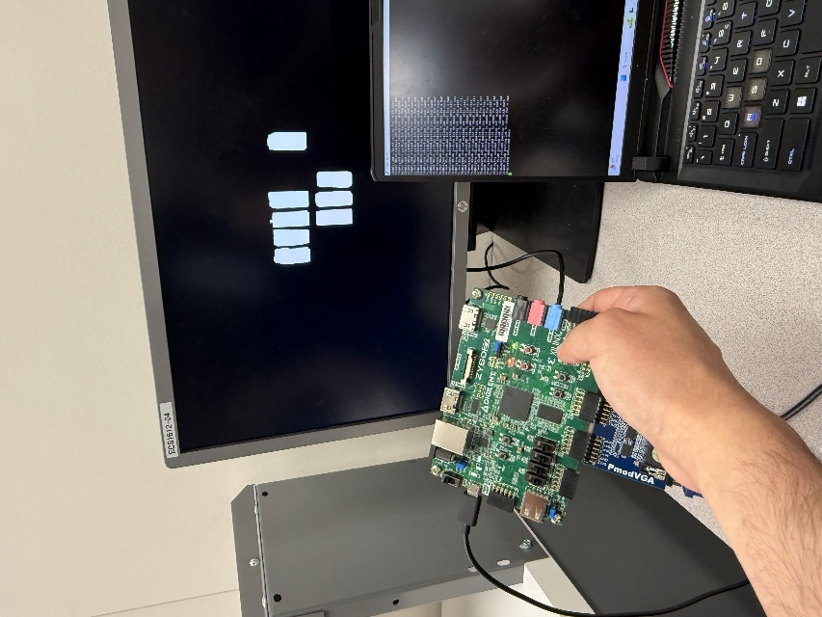

Figure 5.7: Displaying Car mask when the push button value is at 1

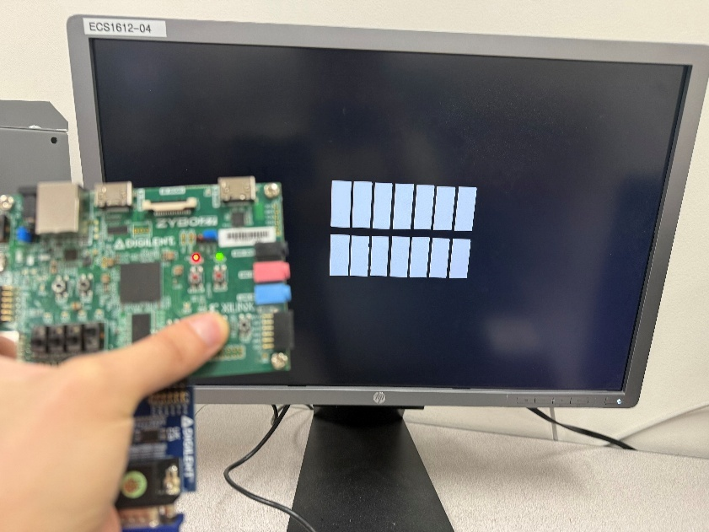

Figure 5.8: Displaying the parking lot mask when push button value is 2

The 4-bit switches are used to choose which parking lot will be analyzed to see if there is a car there or not. Based on the switch's value, it evaluates the chosen centroid coordinate in the parking mask and the car mask and compares the pixel intensity at the parking lot as seen in figures 5.9, 5.10, 5.11, 5.12, 5.13,5.14.

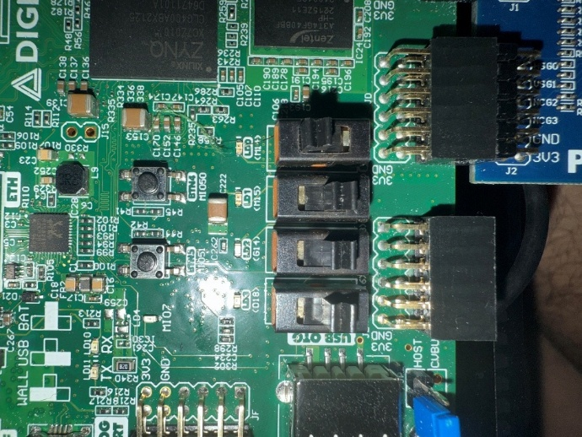

Figure 5.9: 4-bit switch value at 1, choosing to evaluate parking lot 1

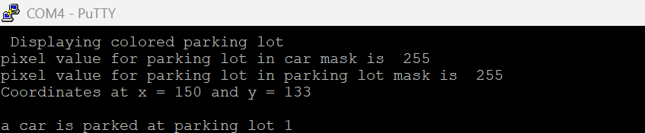

Figure 5.10: Case of car being detected

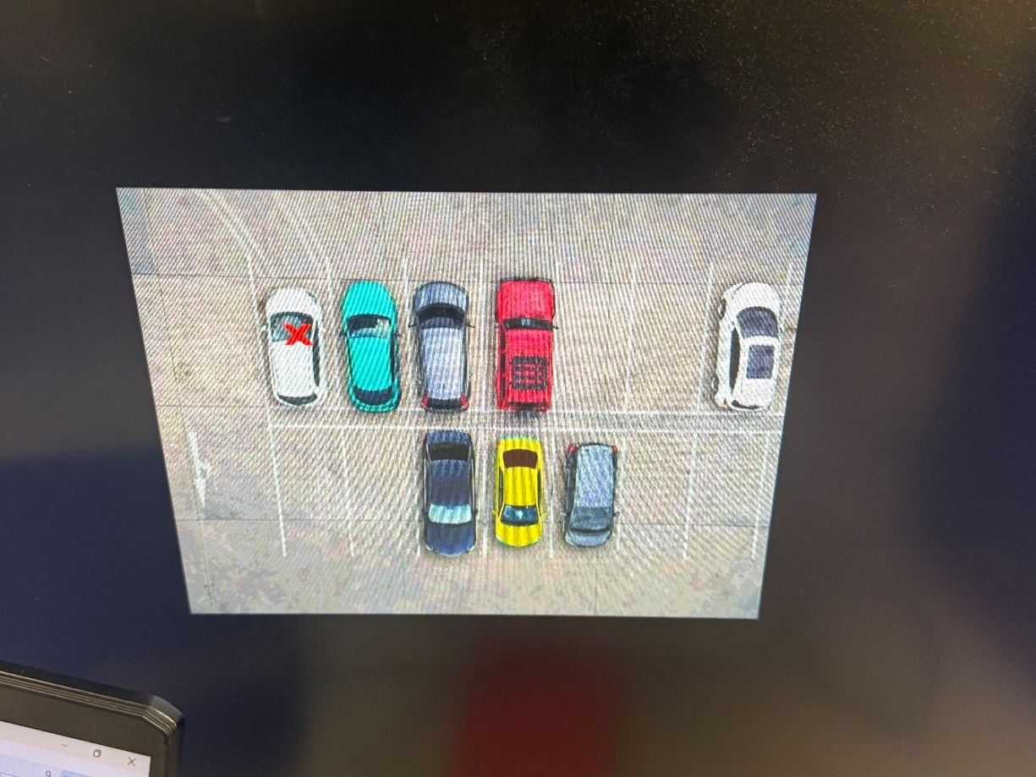

Figure 5.11: Red x being marked in the taken parking spot 1

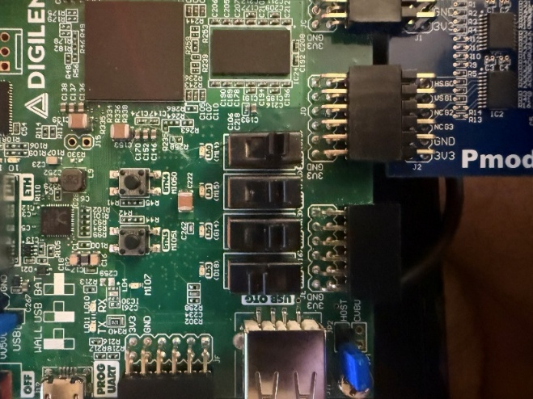

Figure 5.12: 4-bit switch value at 8 choosing to evaluate parking lot 8

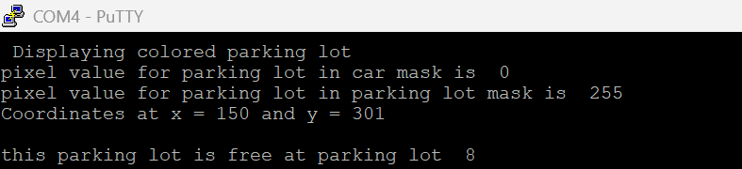

Figure 5.13: Case of a parking space being free

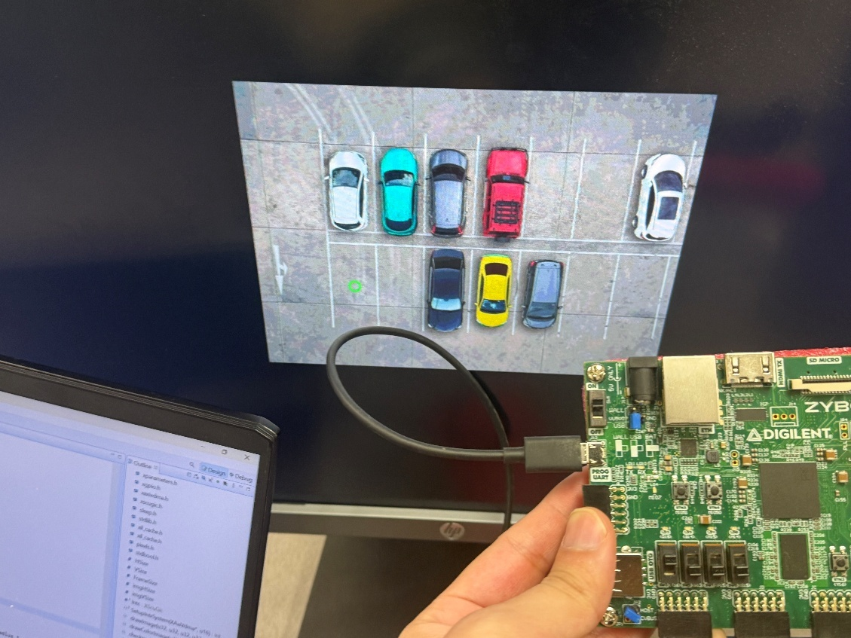

Figure 5.14: Green circle being drawn in response of parking lot 8 being free

## 5.4 Future work

There is one major improvement that could be made in the future that would significantly improve this project. A major improvement that could be made in this project is to make an HLS core that implements morphological operations so the project is less reliant on MATLAB. Having an HLS core that does the image processing would significantly improve the hardware aspect of this project.

## 5.5 Conclusion

This project utilized two platforms to create a real-time parking detector in MATLAB, and Xilinx. The MATLAB portion of this project was successful at extracting the cars and parking lots from the original image and created two masks that are used to detect the cars in the parking lot. The Xilinx part of the project was successful at creating a hardware and software design that uses our processed images obtained from MATLAB and performs real-time parking detection. The GPIO was successfully implemented to switch between images and go to a selected parking spot. In conclusion this project successfully created a real time parking detection.

# References

[1] Dr. Myung Cho, ECE 551 Lecture Notes, California State University Northridge.

[2] Dr. Shahnam Mirzaei, ECE 551 Lecture Notes, California State University Northridge.

[3] “Zybo Z7: Zynq-7000 ARM/FPGA SOC Development Board.” Digilent, digilent.com/shop/zybo-z7-zynq-7000-arm-fpga-soc-development-board/.

[4] “Empty Parking Lots, Aerial View.” *iStock*, nonnie192, 18 Jan. 2017, www.istockphoto.com/photo/empty-parking-lots-aerial-view-gm636373982-112868015.

[5] “PMOD VGA: Video Graphics Array.” Digilent, digilent.com/shop/pmod-vga-video graphics-array/.

[6] Malik, Shahbaz Hasan Khan. California State University, Northridge, p. 48, *Hardware Acceleration of Canny Edge Detection on FPGA Using High Level Synthesis*.

[7] Gonzalez, Rafael C., and Richard E. Woods. *Digital Image Processing*. Prentice Hall,Upper Saddle River

[8] “Zybo Z7 Reference Manual - Digilent Reference.” *Digilent.Com*, 21 Feb. 2018, digilent.com/reference/programmable-logic/zybo-z7/reference-manual.

# Appendix A

## Detect_parking_space.m MATLAB file

%{

% detect_parkin_space.m

% Ryan Mark

% Final Masters Project

%}

clc;

clear all;

close all;

%% Loading Images into MATLAB

filledParking = imread("cars2.jpg");

emptyParking = imread("empty2.jpg");

parkingMask = imread("mask2.jpg");

%% Resizing for Zybo

filledParking = imresize(filledParking, [452 640]);

emptyParking = imresize(emptyParking, [452 640]);

parkingMask = imresize(parkingMask, [452 640]);

%% Pre-Processing of Images

% Display filled parking image

fig1 = figure();

fig1.WindowState = 'maximized';

imshow(filledParking);

axis off;

title('Parking filled with cars');

% Display empty parking image

fig2 = figure();

fig2.WindowState = 'maximized';

imshow(emptyParking);

axis off;

title('Empty Parking');

% Display binary parking mask

fig3 = figure();

fig3.WindowState = 'maximized';

bwMask = max(parkingMask, [], 3) == 255; % masks images at maximum intensity of 255

x = bwMask;

se1 = strel('rectangle', [12, 8]); % structuring element

bwMask = imclose(bwMask, se1); % morphological closing to fill holes to clean mask

imwrite(bwMask, 'final_parkmask.bmp');

props = regionprops(bwMask, 'BoundingBox', 'Area', 'Centroid'); % detects object's BoundingBox, Area, and Centroid

imshow(bwMask); % display binary mask

m = 1; % variable to count and store detected objects (change to 0 when rewriting in C)

for i = 1:length(props)

if props(i).Area > 1000 % check if area of detected object is higher than 1000 to remove noise

allLocations{m} = round(props(i).BoundingBox); % save bounding box locations of detected objects

allCentroids{m} = round(props(i).Centroid); % save centroid locations of detected objects

m = m + 1;

end

end

axis off;

title('Parking Mask');

% Create difference image using fixed-point representation

fig4 = figure();

fig4.WindowState = 'maximized';

T = numerictype(1, 16, 0); % signed, 16 bits, 0 fraction bits

A = fi(filledParking, T);

B = fi(emptyParking, T);

diffImage = abs(A - B);

diffImage = cast(diffImage, "like", A);

diffImage = uint8(diffImage);

imshow(diffImage);

axis off;

title('Difference Image');

% Convert difference image to grayscale and mask it

fig5 = figure();

fig5.WindowState = 'maximized';

diffImage = rgb2gray(diffImage); % grayscale conversion

diffImage(~bwMask) = 0; % set all pixels outside the mask to 0

imshow(diffImage);

axis off;

title('Gray Scale Difference Image');

grayI = diffImage;

imwrite(grayI, "final_graycars.jpg");

% Apply threshold and morphological operations

threshold = 16; % threshold value of 16

parkedCars = diffImage > threshold; % apply threshold

fig6 = figure();

fig6.WindowState = 'maximized';

imshow(parkedCars);

axis off;

title('Thresholded image');

se = ones(25, 10); % structuring element

%% my morphological operation function

parkedCars = Morph_Cars(parkedCars,se);

%% morphlogical operation using the built in functions

%parkedCars = imclose(parkedCars, se); % fill the holes

%parkedCars = imopen(parkedCars, se); % erode the image to clean small noise

imwrite(parkedCars, 'final_carmask.bmp');

% Display final binary mask of parked cars

fig7 = figure();

fig7.WindowState = 'maximized';

imshow(parkedCars);

axis off;

title(sprintf('Parked Cars Binary Image with Threshold = %.1f', threshold));

% Analyze parked car mask and mark detected cars

iprops = regionprops(bwMask, parkedCars, 'BoundingBox', 'MeanIntensity'); % detect Bounding Box and Mean Intensity

m = 1;

for i = 1:length(iprops)

if iprops(i).MeanIntensity > 0.1 % check if mean intensity > 0.1

rectangle('Position', iprops(i).BoundingBox, 'EdgeColor', 'y', 'LineWidth', 2); % yellow box around detected car

takenLocations{m} = iprops(i).BoundingBox; % save bounding box info

m = m + 1;

end

end

% Final result visualization with green O and red X

fig8 = figure();

imshow(filledParking);

fig8.WindowState = 'maximized';

for i = 1:length(allLocations)

taken = false;

box1 = allLocations{i};

r1 = rectangle('Position', box1, 'EdgeColor', 'r', 'LineWidth', 2); % red box for all spots

for j = 1:length(takenLocations)

box2 = takenLocations{j};

r2 = rectangle('Position', box2, 'EdgeColor', 'y', 'LineWidth', 2); % yellow box for detected cars

ratio = bboxOverlapRatio(box1, box2); % check if boxes overlap

if ratio > 0.1

cent = allCentroids{i};

hold on;

plot(cent(1), cent(2), '-x', 'Color', 'r', 'MarkerSize', 25, 'LineWidth', 8); % red X for taken

hold off;

taken = true;

break;

end

end

if ~taken

cent = allCentroids{i};

hold on;

plot(cent(1), cent(2), '-o', 'Color', 'g', 'MarkerSize', 25, 'LineWidth', 8); % green O for available

hold off;

end

end

rect = findall(gcf, 'Type', 'Rectangle'); % detect all rectangles

delete(rect); % delete rectangles after analysis

fig8.Name = 'Results';

title('Marked Spaces. Green O = Available. Red X = Taken.');

# Appendix B

## Morph_Cars.m MATLAB Function file

function y = Morph_Cars(car,se)

x = close(car, se);

y = open(x , se);

end

function erodedImage = erosion(binaryImage, structElem)

% Get dimensions of the binary image and structuring element

[imgRows, imgCols] = size(binaryImage);

[seRows, seCols] = size(structElem);

% Compute padding size for both even and odd kernel sizes

% Compute padding size for even and odd kernel sizes

padTop = floor((seRows - 1) / 2);

padBottom = ceil((seRows - 1) / 2);

padLeft = floor((seCols - 1) / 2);

padRight = ceil((seCols - 1) / 2);

%{

do this for C

const int padTop = (SE_ROWS - 1) / 2;

const int padBottom = SE_ROWS - padTop - 1;

const int padLeft = (SE_COLS - 1) / 2;

const int padRight = SE_COLS - padLeft - 1;

%}

% Create padded image (manually adding zeros around the edges)

paddedImage = zeros(imgRows + padTop + padBottom, imgCols + padLeft + padRight);

for i = 1:imgRows

for j = 1:imgCols

paddedImage(i + padTop, j + padLeft) = binaryImage(i, j);

end

end

% Initialize the eroded image

erodedImage = zeros(imgRows, imgCols);

% Perform erosion

for i = 1:imgRows

for j = 1:imgCols

match = 1; % Assume the structuring element matches

for m = 1:seRows

for n = 1:seCols

% Check if structuring element and region match

if structElem(m, n) == 1 && paddedImage(i + m - 1, j + n - 1) == 0

match = 0; % Mismatch found

break;

end

end

if match == 0

break;

end

end

erodedImage(i, j) = match; % Assign result to output image

end

end

end

% Dilation function

function dilatedImage = dilation(binaryImage, structElem)

% Get dimensions of the binary image and structuring element

[imgRows, imgCols] = size(binaryImage);

[seRows, seCols] = size(structElem);

% Compute padding size for even and odd kernel sizes

padTop = floor((seRows - 1) / 2);

padBottom = ceil((seRows - 1) / 2);

padLeft = floor((seCols - 1) / 2);

padRight = ceil((seCols - 1) / 2);

% Create padded image (manually adding zeros around the edges)

paddedImage = zeros(imgRows + padTop + padBottom, imgCols + padLeft + padRight);

for i = 1:imgRows

for j = 1:imgCols

paddedImage(i + padTop, j + padLeft) = binaryImage(i, j);

end

end

% Initialize the dilated image

dilatedImage = zeros(imgRows, imgCols);

% Perform dilation

for i = 1:imgRows

for j = 1:imgCols

match = 0; % Assume no match initially

for m = 1:seRows

for n = 1:seCols

% Check if structuring element overlaps with the region

if structElem(m, n) == 1 && paddedImage(i + m - 1, j + n - 1) == 1

match = 1; % Match found

break;

end

end

if match == 1

break;

end

end

dilatedImage(i, j) = match; % Assign result to output image

end

end

end

% closing function

function closing = close(image ,structElem )

%useing dialation followed by a erosion

preim = dilation(image,structElem);

closing = erosion(preim,structElem);

end

function opening = open(image ,structElem )

%useing erosion followed by a dialation

preim = erosion(image,structElem);

opening = dilation(preim,structElem);

end

# Appendix C

## Image_write.m MATLAB file

%% writeing image to text MATLAB script to use in vitis

% Ryan Mark

% Read the input grayscale image

img = imread('final_parkmask.bmp'); % Change filename if needed

img = uint8(img)*255;%% normalize back to unsigned 8 bit for the VGA in vitis

% sav resized colorimage

% Open a text file for writing

fid = fopen('parking_mask.txt', 'w');

% Get the size of the resized image

[rows, cols] = size(img);

% Iterate over each pixel and write grayscale values with a comma in between

for r = 1:rows

for c = 1:cols

% Print pixel value with a comma if it's not the last pixel in the row

fprintf(fid, '%d, ', img(r, c));

end

% fprintf(fid, '\n'); % New line at the end of each row

end

% Close the file

fclose(fid);

disp('Grayscale image resized, saved as BMP, and pixel values stored in parkmask.txt with commas.');

%% writing extracted car mask to textfile

% Read the input grayscale image

img = imread('final_carmask.bmp'); % Change filename if needed

img = uint8(img)*255;

% Resize the image to 640x452

%%resized_img = uint8(imresize(img, [452 640])) *255; % recconvert;

%img = imresize(img, [452 640]); % recconvert;

% Save the resized grayscale image as BMP

%%imwrite(resized_img, 'carmask.bmp');

% sav resized colorimage

% Open a text file for writing

fid = fopen('car_mask.txt', 'w');

% Get the size of the resized image

[rows, cols] = size(img);

% Iterate over each pixel and write grayscale values with a comma in between

for r = 1:rows

for c = 1:cols

% Print pixel value with a comma if it's not the last pixel in the row

fprintf(fid, '%d, ', img(r, c));

end

% fprintf(fid, '\n'); % New line at the end of each row

end

% Close the file

fclose(fid);

disp('Grayscale image resized, saved as BMP, and pixel values stored in parkmask.txt with commas.');

%}

%% Colored Image writeing

img = imread('colored_car.bmp'); % Change filename if needed

% Get the size of the resized image

%

[rows, cols, channels] = size(img);

% Iterate over each pixel and write RGB values with a comma in between

fid = fopen('color_car.txt', 'w');

for r = 1:rows

for c = 1:cols

hex_value = uint32(img(r, c, 1)) * 65536 + ... % Shift Red to bits 16-23

uint32(img(r, c, 2)) * 256 + ... % Shift Green to bits 8-15

uint32(img(r, c, 3));

fprintf(fid, '0x%06X, ', hex_value);

end

%fprintf(fid, '\n'); % New line at the end of each row

end

% Close the file

fclose(fid);

disp('Image resized, saved as BMP, and RGB values stored in RGB_Values.txt with commas.');

%}

# Appendix D

## Vitis C code

/*

* Vitis c code for Master project

*

*

* Ryan Mark

*/

**#include** "xparameters.h"

**#include** "xgpio.h"

**#include** "xaxivdma.h"

**#include** "xscugic.h"

**#include** "sleep.h"

**#include** <stdlib.h>

**#include** "xil_cache.h"

**#include** "pixels.h"

**#include** <stdbool.h>

**#define** HSize 1920 // display length for monitor

**#define** VSize 1080 // display width for monitor

**#define** FrameSize HSize*VSize*3

//my image data parameters

**#define** imgHSize 640 // width

**#define** imgVSize 452// length

**static** XScuGic Intc;

**int** activeBuffer = 0;// Allows us to switch buffer whenever GPIO are updated

**static** **int** **SetupIntrSystem**(XAxiVdma *AxiVdmaPtr, u16 ReadIntrId);

**int** **drawImage**(u32 displayHSize,u32 displayVSize,u32 imageHSize,u32 imageVSize,u32 hOffset, u32 vOffset,**unsigned** **char** *imagePointer, **int** activeBuffer);

**int** **drawColorImage**(u32 displayHSize,u32 displayVSize,u32 imageHSize,u32 imageVSize,u32 hOffset, u32 vOffset,**unsigned** **int** *imagePointer, **int** activeBuffer);

**int** **checkparking**(u32 imageHSize,u32 imageVSize,**int** X ,**int** Y , **unsigned** **char** *image1 ,**unsigned** **char** *image2,u32 dip,**int** activeBuffer);

**void** **drawRedX**(**int** centerX, **int** centerY,**int** activeBuffer);

**void** **drawGreenCircle**(**int** centerX, **int** centerY,**int** activeBuffer);

**int** **select_image**(u32 btn ,**int** activeBuffer );

**unsigned** **char** Buffer[2][FrameSize]; // 2 buffers

**int** **main**(){

// image coordinate for parking lots

**int** centroid [14][2] = {{150,133},{224,133},{296,135},{370,135},{444,136},{517,138},{591,138},

{150,301},{223,301},{296,300},{370,301},{442,301},{515,300},{590,302}

};

//GIPO for button and switch

// GPIO Switch set up

XGpio dip;

u32 dip_check;

// Use XGpio_Initialize to initialize the DIP GPIO device

XGpio_Initialize(&dip, XPAR_AXI_GPIO_1_DEVICE_ID);

// Use XGpio_SetDataDirection to set the input/output direction

XGpio_SetDataDirection(&dip, 1, 0xFFFFFFFF);

//GPIO button setup

XGpio btn;

u32 btn_check;

// initialize push button the push button control which image will be displayed

XGpio_Initialize(&btn, XPAR_AXI_GPIO_0_DEVICE_ID);

XGpio_SetDataDirection(&btn, 1, 0xFFFFFFFF);

//VGA and VDMA setup

**int** status;

XAxiVdma myVDMA;

XAxiVdma_Config *config = XAxiVdma_LookupConfig(XPAR_AXI_VDMA_0_DEVICE_ID);

XAxiVdma_DmaSetup ReadCfg;

status = XAxiVdma_CfgInitialize(&myVDMA, config, config->BaseAddress);

**if**(status != XST_SUCCESS){

xil_printf("DMA Initialization failed");

}

ReadCfg.VertSizeInput = VSize;

ReadCfg.HoriSizeInput = HSize*3;

ReadCfg.Stride = HSize*3;

ReadCfg.FrameDelay = 0;

ReadCfg.EnableCircularBuf = 1;

ReadCfg.EnableSync = 1;

ReadCfg.PointNum = 0;

ReadCfg.EnableFrameCounter = 0;

ReadCfg.FixedFrameStoreAddr = 0;

status = XAxiVdma_DmaConfig(&myVDMA, XAXIVDMA_READ, &ReadCfg);

**if** (status != XST_SUCCESS) {

xil_printf("Write channel config failed %d\r\n", status);

**return** status;

}

ReadCfg.FrameStoreStartAddr[0] = (u32)&Buffer[0][0];

ReadCfg.FrameStoreStartAddr[1] = (u32)&Buffer[1][0];

status = XAxiVdma_DmaSetBufferAddr(&myVDMA, XAXIVDMA_READ,ReadCfg.FrameStoreStartAddr);

**if** (status != XST_SUCCESS) {

xil_printf("Read channel set buffer address failed %d\r\n", status);

**return** XST_FAILURE;

}

XAxiVdma_IntrEnable(&myVDMA, XAXIVDMA_IXR_COMPLETION_MASK, XAXIVDMA_READ);

SetupIntrSystem(&myVDMA, XPAR_FABRIC_AXI_VDMA_0_MM2S_INTROUT_INTR);

status = XAxiVdma_DmaStart(&myVDMA,XAXIVDMA_READ);

**if** (status != XST_SUCCESS) {

**if**(status == XST_VDMA_MISMATCH_ERROR)

xil_printf("DMA Mismatch Error\r\n");

**return** XST_FAILURE;

}

**int** prev_btn = 0xfffff;

**int** prev_dip = 0;

**while**(1){

**int** change = 0;

btn_check = XGpio_DiscreteRead(&btn, 1);

dip_check = XGpio_DiscreteRead(&dip, 1);

**if** (btn_check!= prev_btn)

{

change ++;

prev_btn = btn_check;

activeBuffer = 1 - activeBuffer;

select_image( btn_check , activeBuffer );

}

**if** ( dip_check!= prev_dip )

{

prev_dip = dip_check;

change ++;

**if**(change == 2)

{

activeBuffer = activeBuffer; // buffer does not change if the button and switch change in the same iteration

}

**else**

{

activeBuffer = 1 - activeBuffer;

}

select_image( btn_check , activeBuffer ); // rewrite the same image in new buffer so we can add in the over lay of the symbol when a car is taken or not

}

**if**( dip_check >0 && dip_check <15 )

{

**int** x = centroid [dip_check -1] [0]; // define x coordinate of the image

**int** y = centroid [dip_check - 1] [1]; // define y coordinate of the image

checkparking(imgHSize,imgVSize,x,y,carmask,parking_mask,dip_check, activeBuffer);

}

**else**{

xil_printf("Select Which parking lot to check for a car \r\n");

}

XAxiVdma_StartParking(&myVDMA, activeBuffer, XAXIVDMA_READ);

usleep(500000);

//sleep(1);

}

}

/*****************************************************************************/

/* Call back function for read channel

******************************************************************************/

**static** **void** **ReadCallBack**(**void** *CallbackRef, u32 Mask)

{

/* User can add his code in this call back function */

//xil_printf("Read Call back function is called\r\n");

//activeBuffer = 1 - activeBuffer;

}

/*****************************************************************************/

/*

* The user can put his code that should get executed when this

* call back happens.

*

*

******************************************************************************/

**static** **void** **ReadErrorCallBack**(**void** *CallbackRef, u32 Mask)

{

/* User can add his code in this call back function */

//xil_printf("Read Call back Error function is called\r\n");

}

**static** **int** **SetupIntrSystem**(XAxiVdma *AxiVdmaPtr, u16 ReadIntrId)

{

**int** Status;

XScuGic *IntcInstancePtr =&Intc;

/* Initialize the interrupt controller and connect the ISRs */

XScuGic_Config *IntcConfig;

IntcConfig = XScuGic_LookupConfig(XPAR_PS7_SCUGIC_0_DEVICE_ID);

Status = XScuGic_CfgInitialize(IntcInstancePtr, IntcConfig, IntcConfig->CpuBaseAddress);

**if**(Status != XST_SUCCESS){

xil_printf("Interrupt controller initialization failed..");

**return** -1;

}

Status = XScuGic_Connect(IntcInstancePtr,ReadIntrId,(Xil_InterruptHandler)XAxiVdma_ReadIntrHandler,(**void** *)AxiVdmaPtr);

**if** (Status != XST_SUCCESS) {

xil_printf("Failed read channel connect intc %d\r\n", Status);

**return** XST_FAILURE;

}

XScuGic_Enable(IntcInstancePtr,ReadIntrId);

Xil_ExceptionInit();

Xil_ExceptionRegisterHandler(XIL_EXCEPTION_ID_INT,(Xil_ExceptionHandler)XScuGic_InterruptHandler,(**void** *)IntcInstancePtr);

Xil_ExceptionEnable();

/* Register call-back functions

*/

XAxiVdma_SetCallBack(AxiVdmaPtr, XAXIVDMA_HANDLER_GENERAL, ReadCallBack, (**void** *)AxiVdmaPtr, XAXIVDMA_READ);

XAxiVdma_SetCallBack(AxiVdmaPtr, XAXIVDMA_HANDLER_ERROR, ReadErrorCallBack, (**void** *)AxiVdmaPtr, XAXIVDMA_READ);

**return** XST_SUCCESS;

}

**int** **select_image**(u32 btn_check ,**int** activeBuffer )

{

///Push button control which image gets displayed

**if** (btn_check ==1 )

{

drawImage(HSize,VSize,imgHSize,imgVSize,(HSize-imgHSize)/2,(VSize-imgVSize)/2,carmask,activeBuffer);

xil_printf("Displaying extracted cars \r\n");

}

**else** **if**(btn_check ==2)

{

xil_printf("Displaying parking lot mask \r\n");

drawImage(HSize,VSize,imgHSize,imgVSize,(HSize-imgHSize)/2,(VSize-imgVSize)/2,parking_mask,activeBuffer);

}

**else**

{

xil_printf("Displaying colored parking lot \r\n");

drawColorImage(HSize,VSize,imgHSize,imgVSize,(HSize-imgHSize)/2,(VSize-imgVSize)/2,color_car,activeBuffer);

}

Xil_DCacheFlush();

**return** 0;

}

// draw image for grayscale/binary image reconverted to unint8

**int** **drawImage**(u32 displayHSize,u32 displayVSize,u32 imageHSize,u32 imageVSize,u32 hOffset, u32 vOffset,**unsigned** **char** *imagePointer,**int** activeBuffer){

**for**(**int** i=0;i<VSize;i++){

**for**(**int** j=0;j<HSize;j++){

**if**(i<vOffset || i >= vOffset+imageVSize){

Buffer[activeBuffer][(i*HSize*3)+(j*3)] = 0x00;

Buffer[activeBuffer][(i*HSize*3)+(j*3)+1] = 0x00;

Buffer[activeBuffer][(i*HSize*3)+(j*3)+2] = 0x00;

}

**else** **if**(j<hOffset || j >= hOffset+imageHSize){

Buffer[activeBuffer][(i*HSize*3)+(j*3)] = 0x00;

Buffer[activeBuffer][(i*HSize*3)+(j*3)+1] = 0x00;

Buffer[activeBuffer][(i*HSize*3)+(j*3)+2] = 0x00;

}

**else** {

Buffer[activeBuffer][(i*HSize*3)+j*3] = *imagePointer >> 4;

Buffer[activeBuffer][(i*HSize*3)+(j*3)+1] = *imagePointer >> 4;

Buffer[activeBuffer][(i*HSize*3)+(j*3)+2] = *imagePointer >> 4;

imagePointer++;

}

}

}

Xil_DCacheFlush();

**return** 0;

}

**int** **drawColorImage**(u32 displayHSize,u32 displayVSize,u32 imageHSize,u32 imageVSize,u32 hOffset, u32 vOffset,**unsigned** **int** *imagePointer,**int** activeBuffer){

**for**(**int** i=0;i<VSize;i++){

**for**(**int** j=0;j<HSize;j++){

//pixel out of frame become black

**if**(i<vOffset || i >= vOffset+imageVSize){

Buffer[activeBuffer][(i*HSize*3)+(j*3)] = 0x00;

Buffer[activeBuffer][(i*HSize*3)+(j*3)+1] = 0x00;

Buffer[activeBuffer][(i*HSize*3)+(j*3)+2] = 0x00;

}

**else** **if**(j<hOffset || j >= hOffset+imageHSize){

Buffer[activeBuffer][(i*HSize*3)+(j*3)] = 0x00;

Buffer[activeBuffer][(i*HSize*3)+(j*3)+1] = 0x00;

Buffer[activeBuffer][(i*HSize*3)+(j*3)+2] = 0x00;

}

**else** {

uint8_t Red = (*imagePointer & 0xFF0000) >> 16; //extracting red pixel

uint8_t Green = (*imagePointer & 0xFF00) >> 8; // extracting green pixel

uint8_t Blue = (*imagePointer & 0xFF); // extracting blue pixel

// assign pixel to buffer while normalize pixels to 4 bits

Buffer[activeBuffer][(i*HSize*3)+j*3] = Red >> 4;// red channel

Buffer[activeBuffer][(i*HSize*3)+(j*3)+1] = Green >> 4; // green channel

Buffer[activeBuffer][(i*HSize*3)+(j*3)+2] = Blue >> 4; // blue channel

imagePointer++;

}

}

}

Xil_DCacheFlush();

**return** 0;

}

**int** **checkparking**(u32 imageHSize,u32 imageVSize,**int** x ,**int** y , **unsigned** **char** *image1 ,**unsigned** **char** *image2,u32 dip,**int** activeBuffer)

{

**for**(**int** i=0;i<imageVSize;i++)

{

**for**(**int** j=0;j<imageHSize;j++)

{

**if**(i== y && j == x)

{

uint8_t pixel_car = *image1;

uint8_t pixel_mask = *image2;

xil_printf("pixel value for parking lot in car mask is %d\r\n", pixel_car);

xil_printf("pixel value for parking lot in parking lot mask is %d\r\n", pixel_mask);

xil_printf("Coordinates at x = %d and y = %d\r\n", x, y);

**if**(pixel_car == pixel_mask)

{

xil_printf("\na car is parked at parking lot %d\r\n ", dip);

// drawing red x at taken space

**int** screenX = x + (HSize - imgHSize) / 2;

**int** screenY = y + (VSize - imgVSize) / 2;

drawRedX(screenX, screenY, activeBuffer);

//sleep(3); delay previously used for single buffer

}

**else**

{

xil_printf("\nthis parking lot is free at parking lot %d\r\n", dip);

// draw green circle if parking is free

**int** screenX = x + (HSize - imgHSize) / 2;

**int** screenY = y + (VSize - imgVSize) / 2;

drawGreenCircle(screenX, screenY, activeBuffer);

//sleep(3); delay previously used for single buffer

}

}

image1++;

image2++;

}

}

Xil_DCacheFlush();

**return** 0;

}

**void** **drawRedX**(**int** centerX, **int** centerY,**int** activeBuffer) {

**int** size = 10; // Half-length of each diagonal line

**int** thickness = 4; // Thickness of the lines

**for** (**int** i = -size; i <= size; i++) {

**for** (**int** t = -thickness; t <= thickness; t++) {

// Line from top-left to bottom-right

**int** x1 = centerX + i + t;

**int** y1 = centerY + i;

// Line from bottom-left to top-right

**int** x2 = centerX + i + t;

**int** y2 = centerY - i;

// Bounds check and draw pixel

**if** (x1 >= 0 && x1 < HSize && y1 >= 0 && y1 < VSize)

{

**int** index = (y1 * HSize * 3) + (x1 * 3);

Buffer[activeBuffer][index] = 0x0F; // Red

Buffer[activeBuffer][index + 1] = 0x00; // Green

Buffer[activeBuffer][index + 2] = 0x00; // Blue

}

**if** (x2 >= 0 && x2 < HSize && y2 >= 0 && y2 < VSize)

{

**int** index = (y2 * HSize * 3) + (x2 * 3);

Buffer[activeBuffer][index] = 0x0F; // Red

Buffer[activeBuffer][index + 1] = 0x00; // Green

Buffer[activeBuffer][index + 2] = 0x00; // Blue

}

}

}

}

**void** **drawGreenCircle**(**int** centerX, **int** centerY,**int** activeBuffer) {

**int** radius = 10; //radius of the circle

**int** thickness = 3; // assign how thick the circle will be

**for** (**int** iy = -radius; iy <= radius; iy++) // for loop to draw circle

{

**for** (**int** jx = -radius; jx <= radius; jx++)

{

**int** distSquared = jx * jx + iy * iy; //distance formula calculation

**if** (distSquared >= (radius - thickness) * (radius - thickness) && distSquared <= radius * radius) {

**int** px = centerX + jx;// getting x coordinate in point of circle

**int** py = centerY + iy; // getting y coordinate in point of circle

// Makes sure we're within the screen bounds

**if** (px >= 0 && px < HSize && py >= 0 && py < VSize) {

**int** index = (py * HSize * 3) + (px * 3);

Buffer[activeBuffer][index] = 0x00; // Red

Buffer[activeBuffer][index + 1] = 0x0F; // Green

Buffer[activeBuffer][index + 2] = 0x00; // Blue

}

}

}

}

}